s

|  |
| --- |
| Photo displaying partial image of two pie charts on a canvas-textured page |
| Ministry of planning  Supervisors: |
| |  |  |  | | --- | --- | --- | | Talha Alshafeai | 9/28/20 | Web Development | |



Dr. Jalal Kiswani, TA. Hana Rasheed, Miss. Jacquelyn Brown, Mr. William Smairat.

Table of Contents

Figures Table 2

1. Introduction 4

2. Project details 5

A. Technology 5

I. Front-End 5

II. Back-End 6

III. Modelling 6

IV. Version control 6

B. Requirements 7

I. Users Requirements 7

II. Functional Requirements 8

III. Nonfunctional Requirements 8

C. Design 9

I. Sitemap 10

II. Wireframes 11

III. Mockups 12

IV. Prototypes 13

V. ERD (Entity Relational Diagram) 14

D. Testing 15

E. Deployment 16

3. Screen Shots 17

A. Wireframes Screens 17

B. Mockups Screens 33

C. Prototypes Screens 49

4. Source Code excerpts 66

5. Conclusion 68

6. Citation 69

# Figures Table

1 Front-End Technologies [1] 5

2 Back-End Technologies [2] 6

3 Software Requirements [3] 7

4 Sitemap to Wireframe to Mockup [4],[5],[6] 9

5 Sitemap of MOP 11

6 Wireframe-Homepage-first third 12

7 Mockup-Homepage-second-third 13

8 Prototype-Homepage-third-third 14

9 ERD 15

10 Homepage-Wireframe 17

11 About-Wireframe 18

12 Tasks and Duties-Wireframe 19

13 Performance Development-Wireframe 20

14 National Goals-Wireframe 21

15 Organizational Chart/ Strategical Plan--Wireframe 22

16 FAQ-Wireframe 23

17 Ministers/ General Secretaries- Wireframe 24

18 Annual Reports-Wireframe 25

19 Projects and Initiatives-Wireframe 26

20 Services Guide-Wireframe 27

21 Contact Us-Wireframe 28

22 Gallery-Wireframe 29

23 Plans and Programs-Wireframe 30

24 News-Wireframe 31

25 E-Service-Wireframe 32

26 Homepage-Mockup 33

27 About-Mockup 34

28 Annual Reports-Mockup 35

29 Contact Us-Mockup 36

30 FAQ-Mockup 37

31 Gallery-Mockup 38

32 Ministers/General Secretaries-Mockup 39

33 Performance Development-Mockup 40

34 National Goals-Mockup 41

35 News-Mockup 42

36 Organizational Chart/Strategical Plan-Mockup 43

37 Plans and Programs-Mockup 44

38 Projects and Initiatives-Mockup 45

39 Services Guide-Mockup 46

40 Tasks and Duties-Mockup 47

41 Train Students/ Scholarships-Mockup 48

42 Homepage 49

43 About 50

44 Organizational Chart, Strategical Plan (same page, different data) 51

45 Plans and Programs 52

46 FAQ 53

47 Tasks and Duties 54

48 Ministers, General Secretaries (same page, different data) “background is ruined because of full screen screenshot”. 55

49 Annual Reports 56

50 Performance of Development 57

51 Services Guide 58

52 National Goals 59

53 Projects and Initiatives 60

54 News 61

55 News Article 62

56 Gallery 63

57 Contact Us 64

58 E-services pages all look the same 65

Table 1 Test Cases 13

# Introduction

The reason I chose the Ministry of Planning and International Cooperation as my subject in the Capstone project, is that I did not know that this ministry existed. I wanted to learn about the types of work ministries do; especially this one. So, since I cannot go visit them in person and ask them “what do you do?”, I went to their website. I started looking around and checking everything, and I thought to myself “I am going to choose this one because it lacks a lot of modern stuff”. Even though they updated their website a week after I started working, I was determined to make my work even better than theirs. And by “better” I mean more appealing, better user experience, and adding e-services.

I started with the main thing first, which is covering the main functionalities on the original website while giving a new taste of colors. After that, I started thinking of the e-services I am going to add. E-services that could benefit who is interested in this ministry. Imagine you are a college student who is studying Politics, and you get the chance to get trained in a ministry; would you capture the chance or let it slip? That is the first service I added,” Train college students” is a way for students to submit a form to train at the ministry. While surfing the original website, I found a page that contains scholarships. However, that page did not provide any way to submit to them. So, I created my second e-service “Submit to Scholarships”. A way to submit to available scholarships that are sponsored by the ministry.

Lastly, it was time for my third e-service. I came up with an idea that already exists, and it is the newsletter. Why not have a newsletter for the ministry? You can subscribe to it by email. It will provide you with a news highlight of what is going on with the ministry. It will send you a notification when there are new scholarships available. Also, a nice informant about the ministry needs of students to train. Basically, I remodeled the original website of the Ministry of Planning, and I added services with the main goal of them being” a benefit for anyone who is interested” in an easy way.

# Project details

In this section, I will discuss the parts of how I built the system. The technologies I used, the requirements I provided in the system. Also, you will see the design how it was on papers before on browser. Lastly, I will be talking about the test cases I have done in the system.

## Technology

I used a lot of technologies while working on the capstone project; that helped me finish the system according to the requirements. You can find them listed below.

### Front-End

1. HTML (Hyper Text Markup Language)
2. CSS (Cascading Style Sheet)
3. JS (JavaScript)
4. Bootstrap

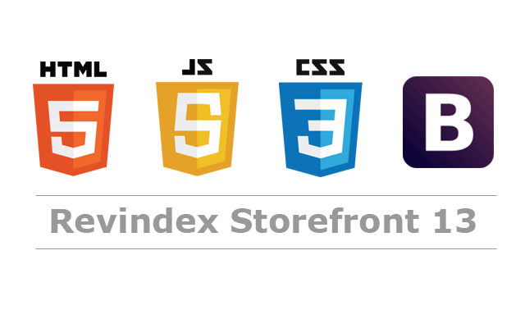

1 Front-End Technologies [1]

### Back-End

1. NodeJS (<https://nodejs.org/en/>)
2. Express (<https://expressjs.com/>)
3. Handlebars (<https://handlebarsjs.com/>): Templating engine for dynamic loading.
4. Joi (<https://joi.dev/>): for validation.



2 Back-End Technologies [2]

### Modelling

1. Sitemap (MS PowerPoint)
2. Wireframes (<https://app.diagrams.net/>) aka draw.io
3. Mockups (<https://www.figma.com/>)
4. ERD (entity relational diagram) (<https://www.lucidchart.com/>)

### Version control

* GitHub (<https://github.com/>)

## Requirements

In the user section of the requirements below, I talk about the screens of what the user will be dealing with while using the system, but with no deep dive into specification. However, I will dive deeper in specs at the functional requirements section and talk about what the system should do. Later, I will talk about how the systems fulfils these requirements in the nonfunctional section.



3 Software Requirements [3]

### Users Requirements

* User can reach the website freely.
* User can submit a message using the contact us page.
* User can subscribe to the newsletter using email.
* User can apply to available scholarships using the e-service.
* User can apply to training at the ministry using the e-service.
* User can navigate news on the website and click on articles.
* User can check out the information about units and departments related to the ministry.
* User can download files that are available on the website.

### Functional Requirements

* System redirects user to main page in case page does not exist.
* Ability to deliver pages to user fast because of Handlebars template engine used for creating views and layouts that sometimes can be repetitive.
* Ability to submit messages to server using express as a backend server, receiving data from the forms through fetch request.
* Ability to receive email submitted from the user and storing it inside the database in the subscription table.
* Ability to apply to available scholarships and store data provided in the database.
* Ability to apply for training in the ministry using the form to submit your data.
* Ability to click on a news article, as it is one of the views generated by Handlebars according to the data stored in the database.
* Ability to check all the information available about the units related to the ministry.
* Ability to download files presented to the user just by clicking.

### Nonfunctional Requirements

* Recoverability due to using express redirect functionality to capture bad requests and return them to the homepage instead of showing them that the page does not exist.
* Availability because every page is created as a Handlebar view, to render exactly what is requested. It is much faster than responding with a whole html page since Handlebars view is embedded inside a default layout that has the main parts written in it like (Header, Footer).
* Maintainability because of how the system is implemented.
* Data integrity because the server should respond within 2 seconds with a message on whether the submitted data are valid or not. Since the server is using Joi to validate the inputs fields to match the required columns and data types in the database.
* Security in the validation part of the email is configured to only accept (.com) emails. So, it will not be stored in the subscription table unless it is valid.
* Usability of the views and layouts.
* The scholarships are fetched dynamically from database as they are stored as look up tables inside the database.
* The dynamic fetching and rendering should be processed withing 5 seconds in e-services pages.
* Generating news article page depends on the identifier of the click from the news page and according to it the article is fetched from database table.
* Files are stored on the server storage and their paths are stored in the database. It should download the specific file when clicked.
* Performance is better than the original website; measured by response time.

## Design

Design process went from studying requirements and main functionalities of website to start drawing the sitemap of the system to determine the pages. After that, wireframing each single page by drawing the structure of it without any colors; then convert them to mockups with colors and pictures.



4 Sitemap to Wireframe to Mockup [4],[5],[6]

### Sitemap

* Every green rectangle is a page on the website.
* You can navigate to pages throughout the menu at the top
* You can submit forms in these pages

1. Contact us. In case you have a message for the ministry
2. Train students. Applying for training.
3. Scholarships. Apply for available scholarships.
4. Newsletter. Subscribe to the weekly newsletter by email.

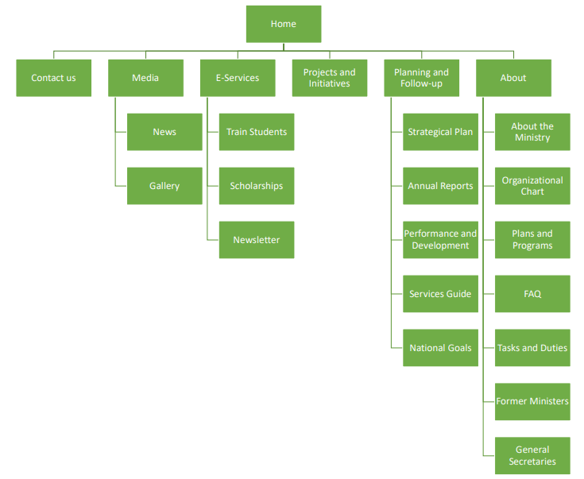

5 Sitemap of MOP

### Wireframes

Wireframe is basically the bones of the website, so it shows the pages in a very plain way and by plain, I mean no colors nor images. Below is the first third of the homepage in wireframe.

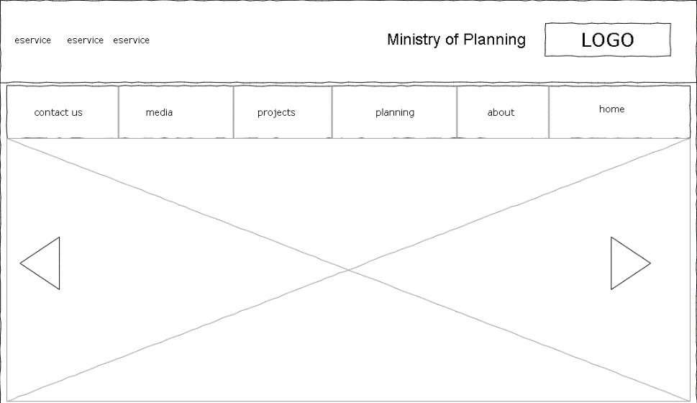

6 Wireframe-Homepage-first third

### Mockups

Mockups is what comes after you are done with the structure; it is time to show some colors. The figure shown below is the second third of homepage in mockups.

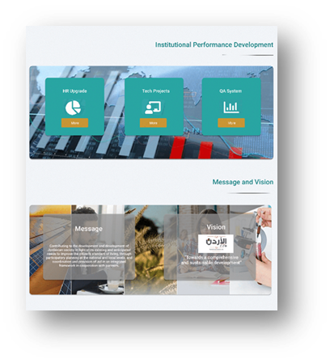

7 Mockup-Homepage-second-third

### Prototypes

Prototypes is the mockups turned into code. Shown below is the third-third of homepage in prototype.

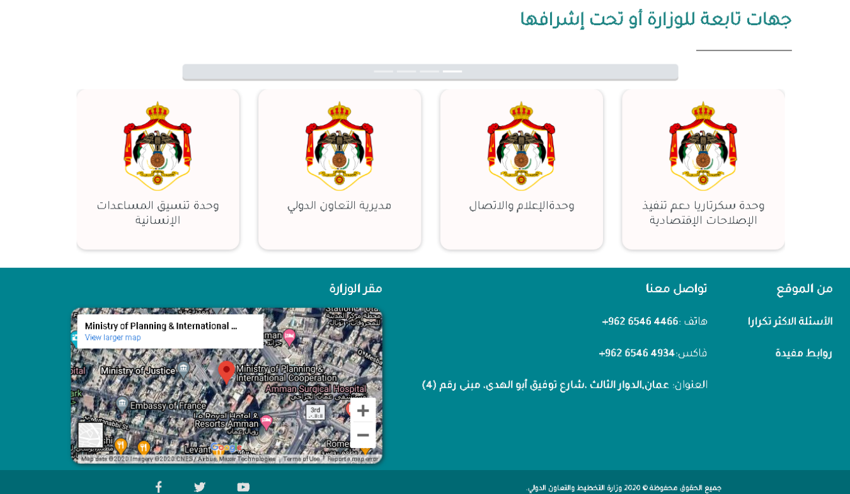

8 Prototype-Homepage-third-third

### ERD (Entity Relational Diagram)

The figure shown below is the ERD of the system. It shows the tables created in the database and the relations between them. They are also divided into color-coded categories.

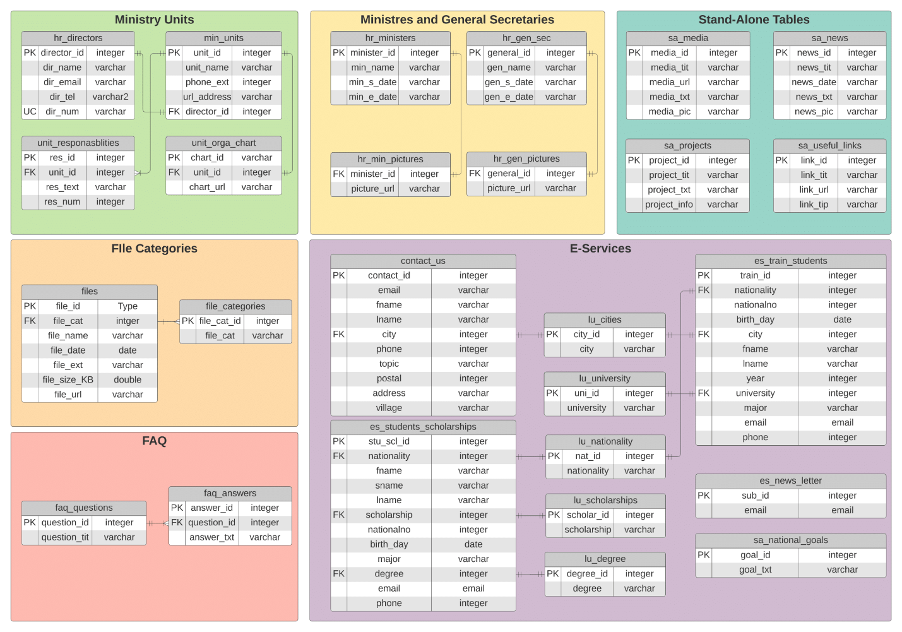

9 ERD

## Testing

Validation is done on the client side using html attributes, but of course that is not enough. The server-side validation is done with Joi. And depending on the result of the validation, a message appears to inform the user if it was submitted correctly or not. In table, P0 is the highest priority.

Table 1 Test Cases

|  |  |  |  |  |  |  |
| --- | --- | --- | --- | --- | --- | --- |
| Test-id | Component | Priority | Description and Steps | Expected result | Actual result | Status |
| Test_1 | Browser URL in the unit’s page. | P0 | Whenever user changes the query parameters in URL manually.  Step1: click on any unit  Step2: try and change the value after “?id=”.  Step3: enter | 404 page not found. | Redirected to homepage. | Pass. |
| Test_2 | Email field in forms. | P2 | When user submits an email with no “.com”.  Step1: go to form and fill data.  Step2: put email with domain name other than “.com”  Step3: Submit | Submit data to server and stores it in database. | Displays a message of how to properly fill the form because of validation. | Pass. |
| Test_3 | Date field in forms. | P2 | Same as test_2, but with email field being a value in the future | Same as test_2 | Same as test_2 | Pass. |
| Test_4 | National number in forms. | P2 | Same as test_2, but with national number being other than 10 digits. | Same as test_2 | Same as test_2 | Pass. |
| Test_5 | Names in forms | P3 | Same as test_2, but with names not accepting a value other than string or being a collection of characters at least 2. | Same as test_2 | Same as test_2 | Pass. |

## Deployment

All the work is submitted to GitHub in a private repository between me and the teacher. The website is not deployed anywhere.

# Screen Shots

## Wireframes Screens

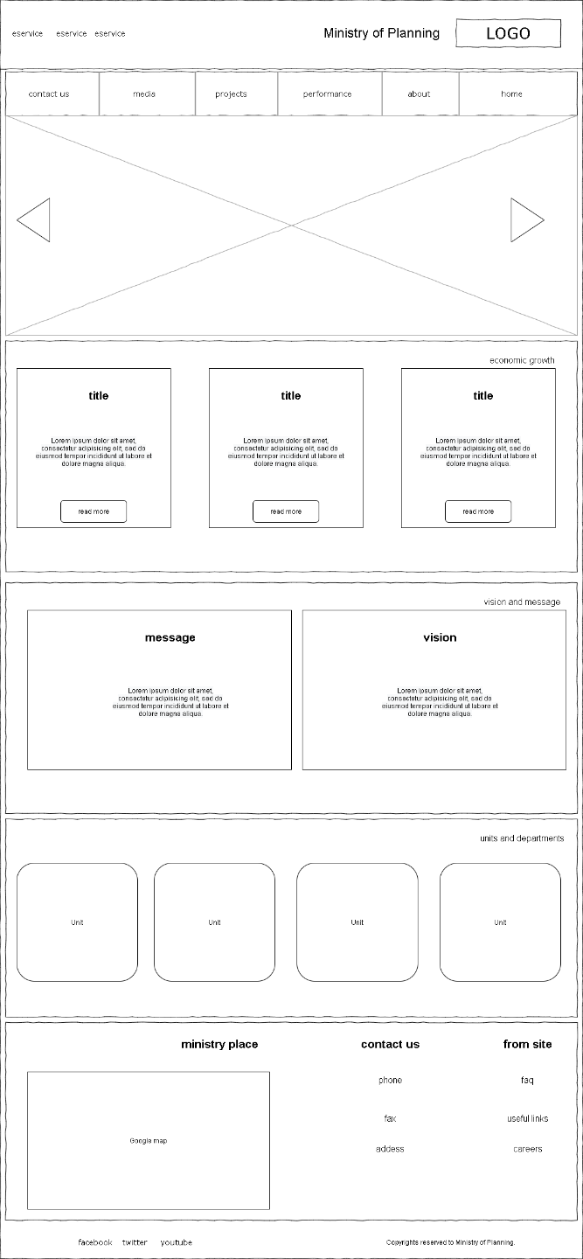

10 Homepage-Wireframe

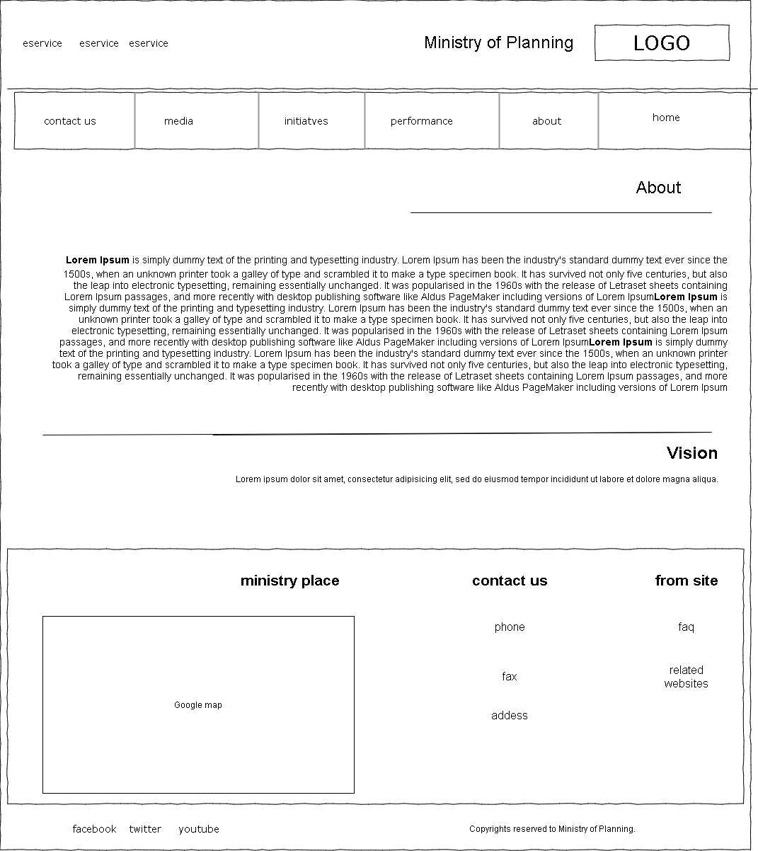

11 About-Wireframe

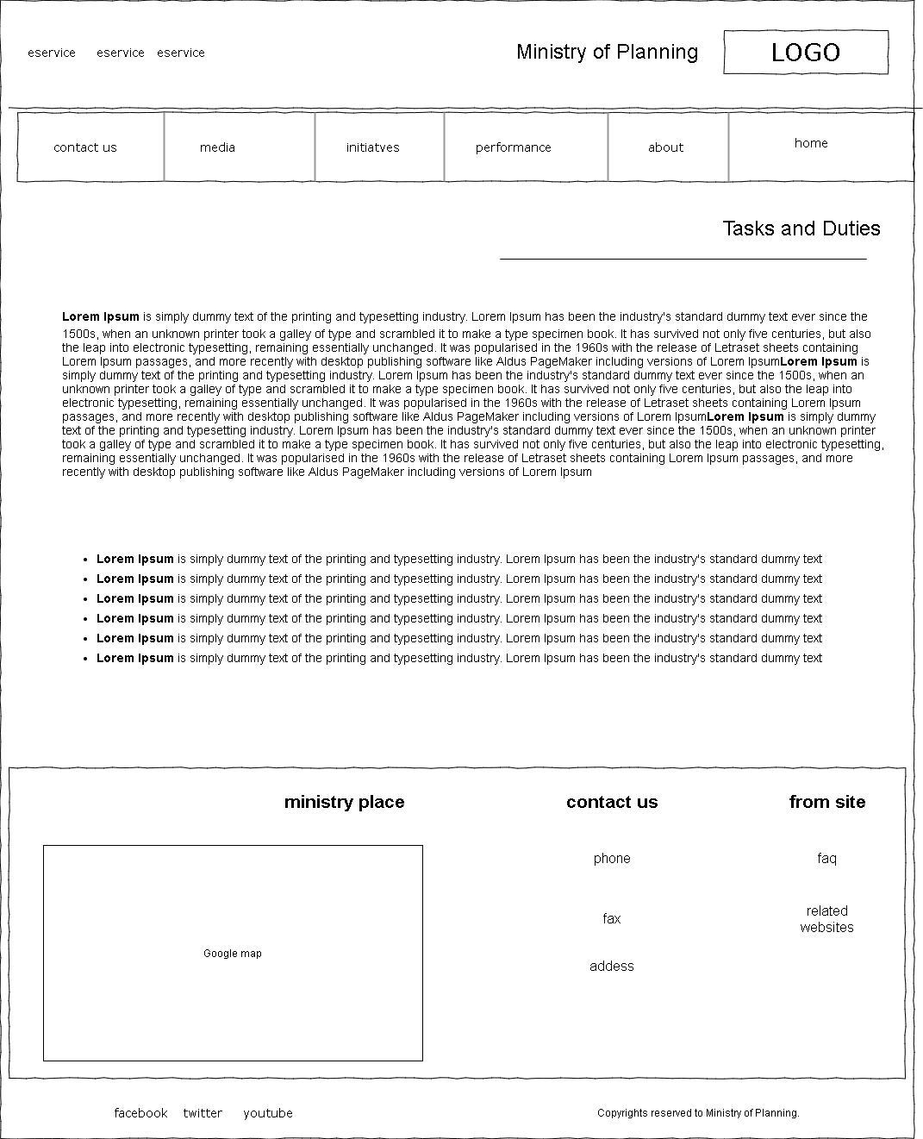

12 Tasks and Duties-Wireframe

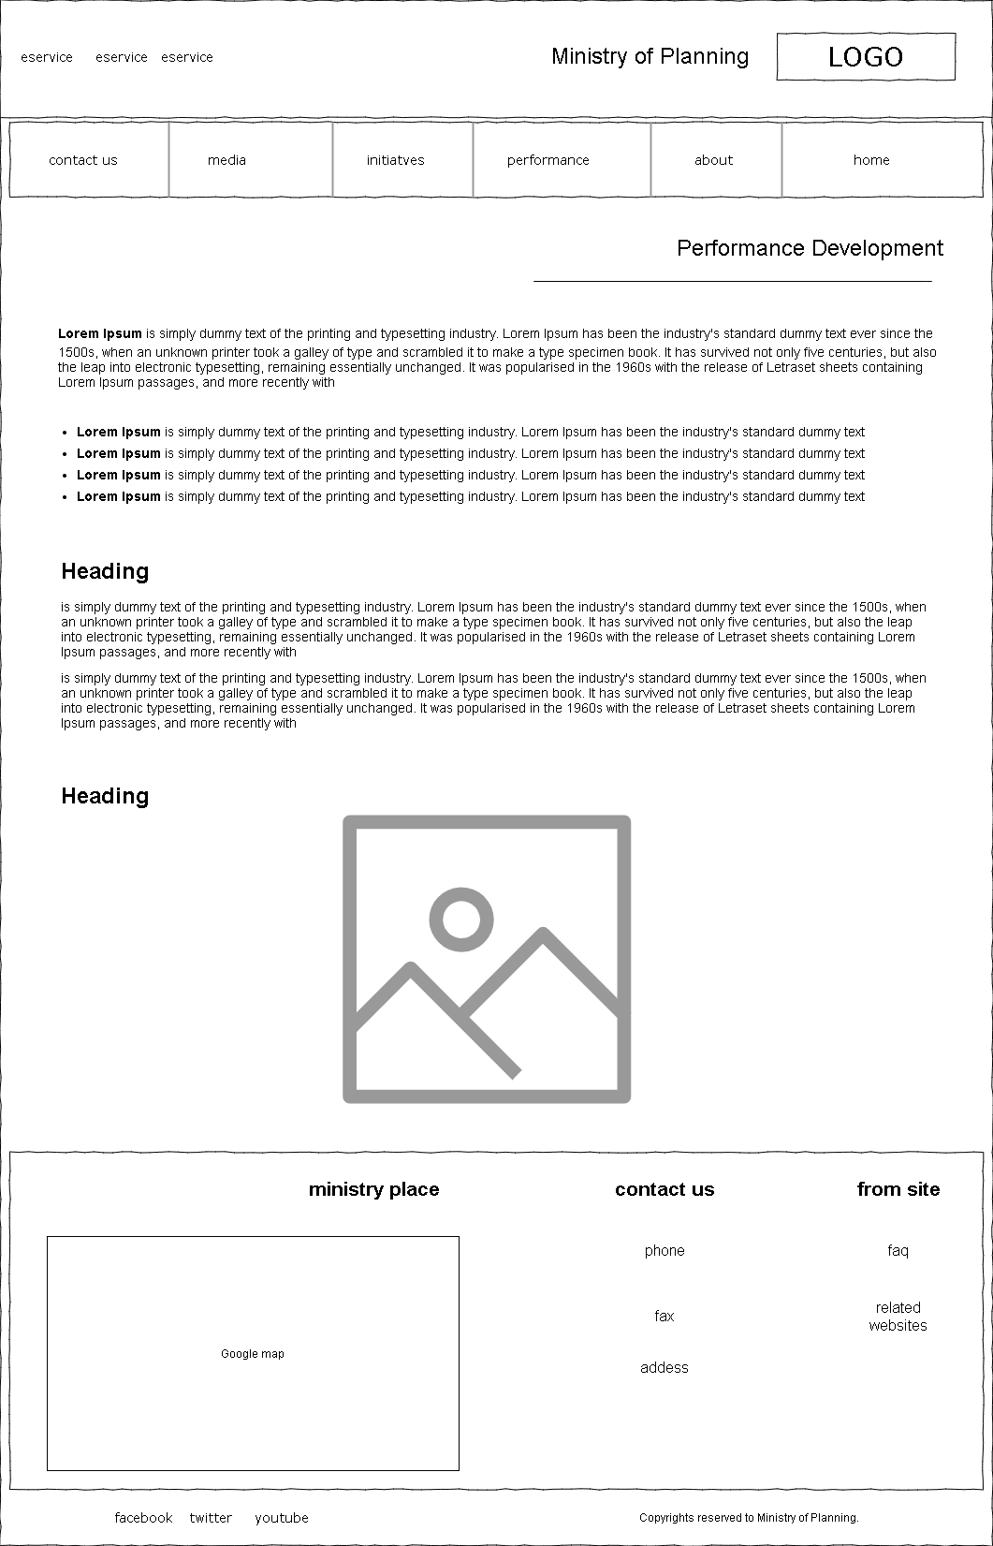

13 Performance Development-Wireframe

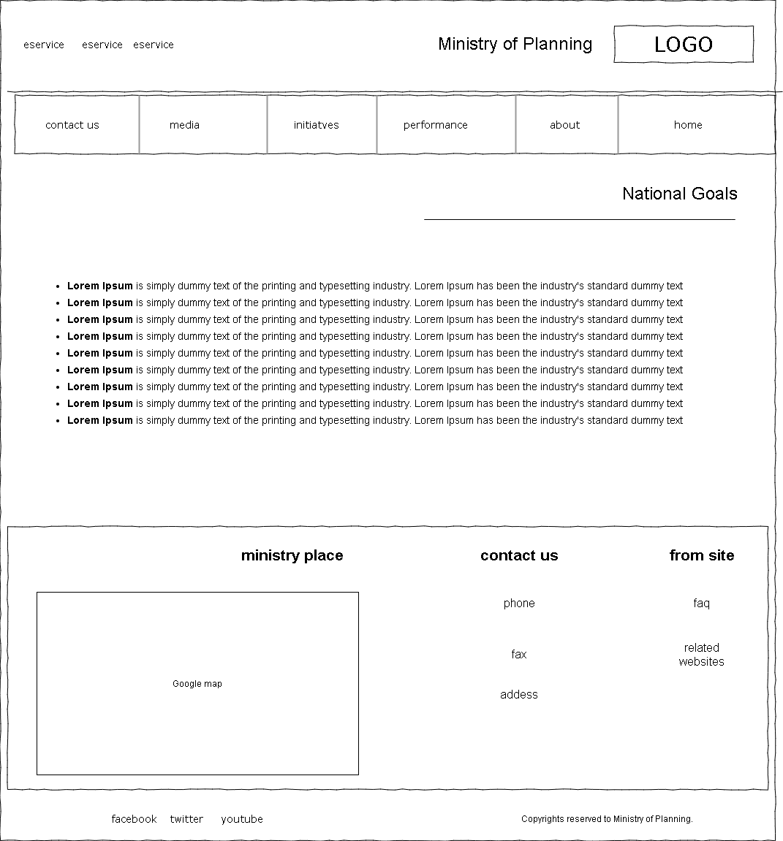

14 National Goals-Wireframe

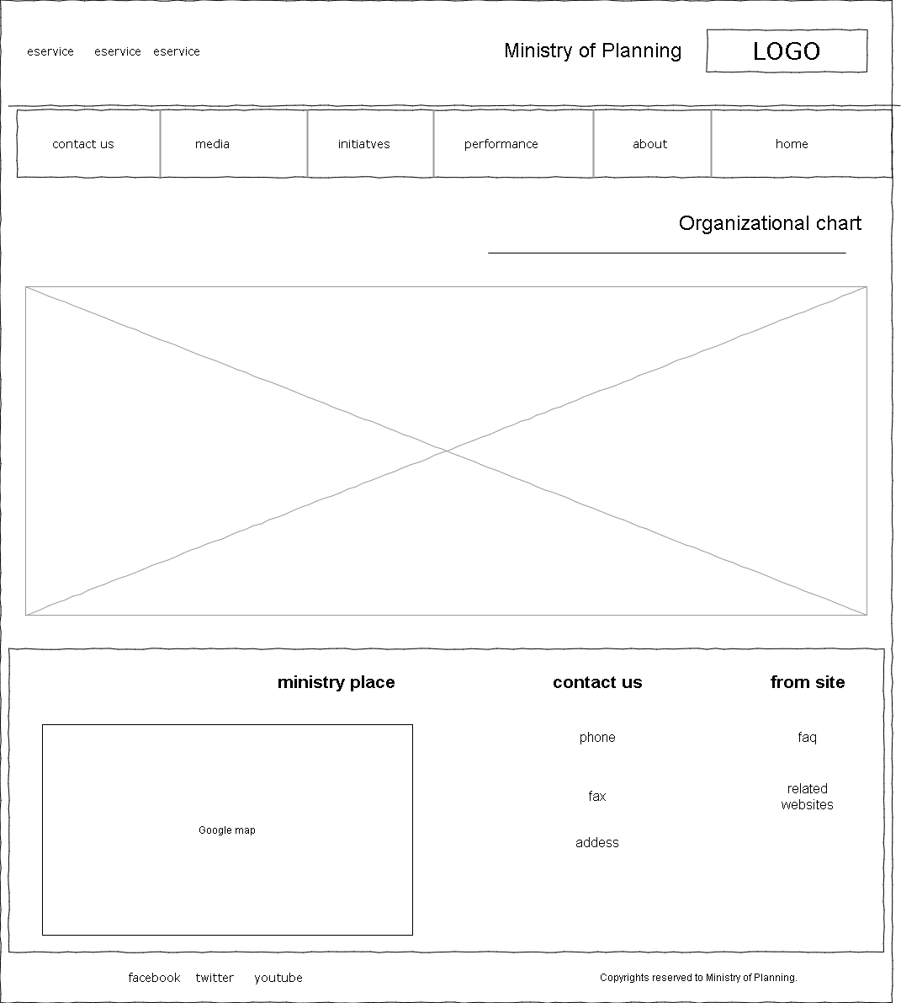

15 Organizational Chart/ Strategical Plan--Wireframe

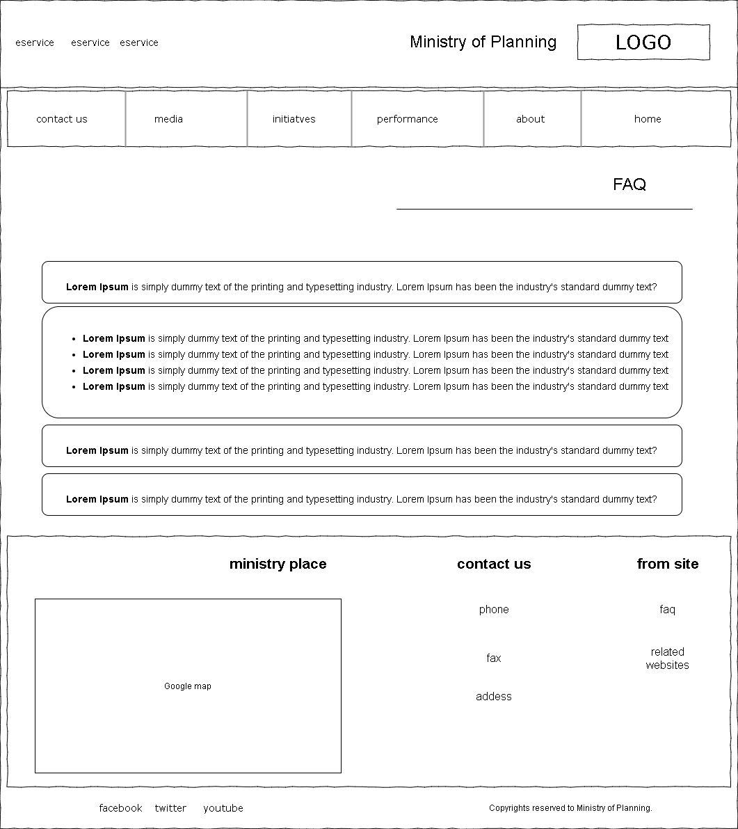

16 FAQ-Wireframe

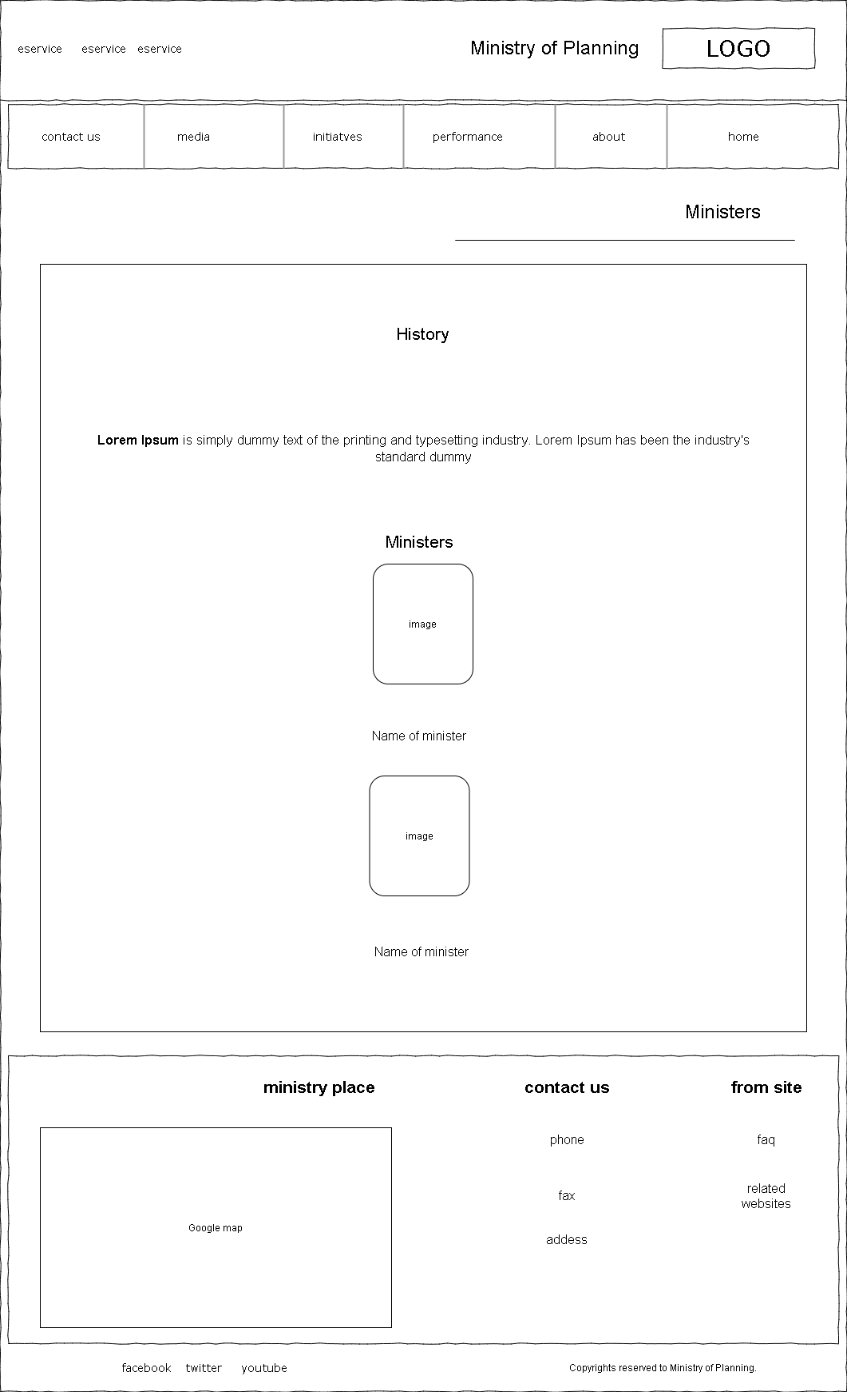

17 Ministers/ General Secretaries- Wireframe

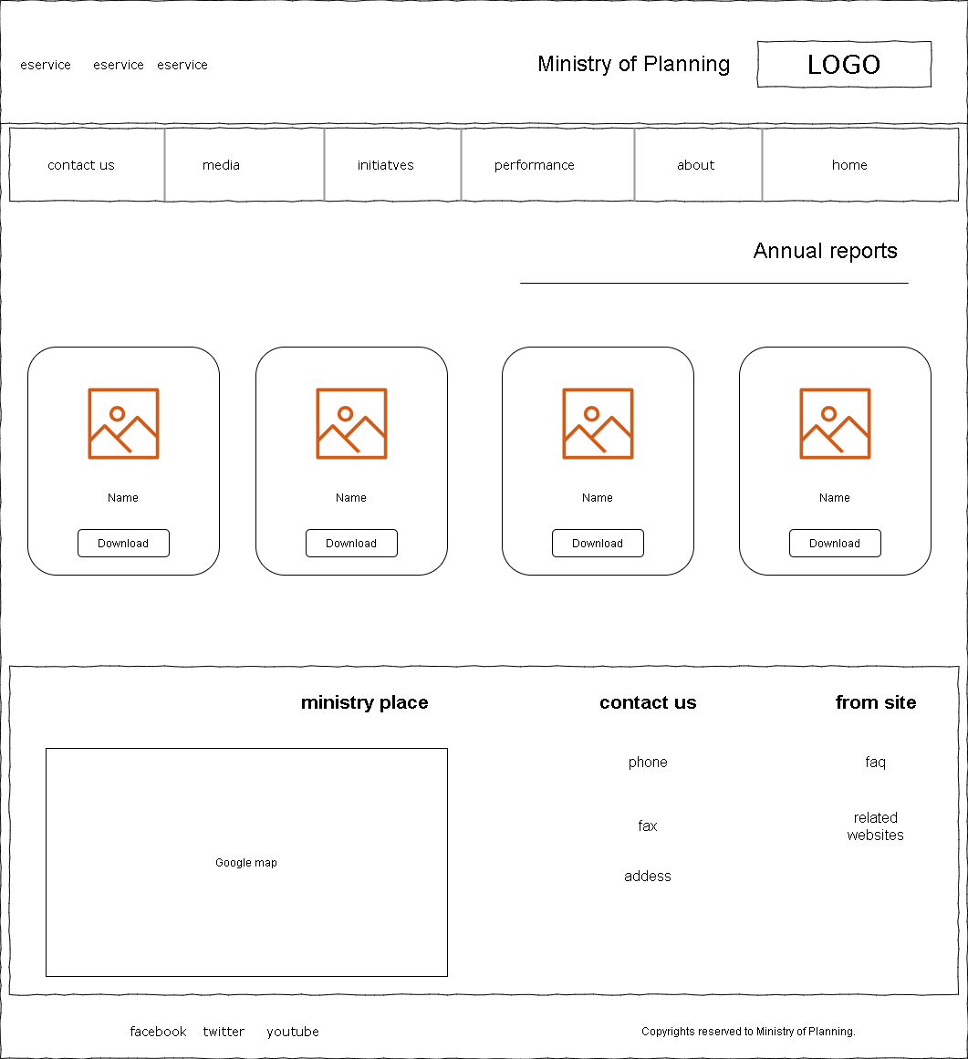

18 Annual Reports-Wireframe

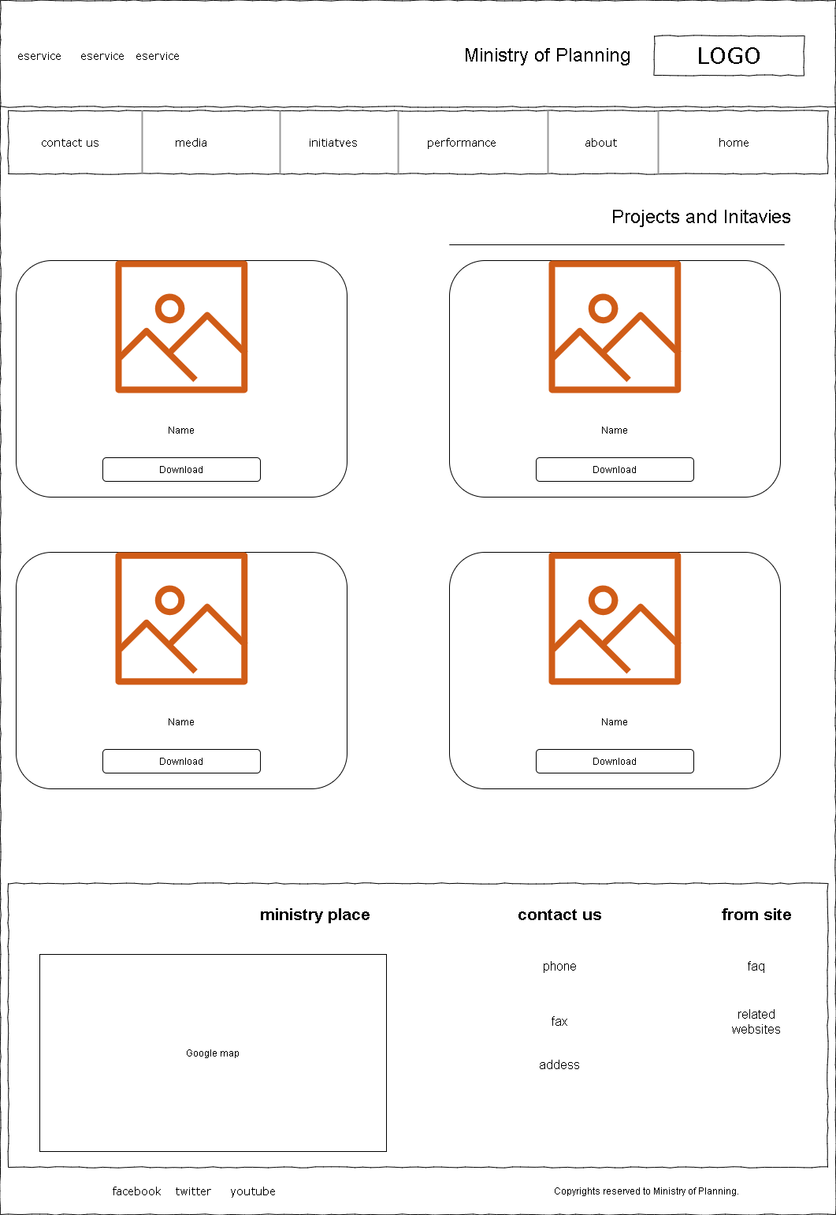

19 Projects and Initiatives-Wireframe

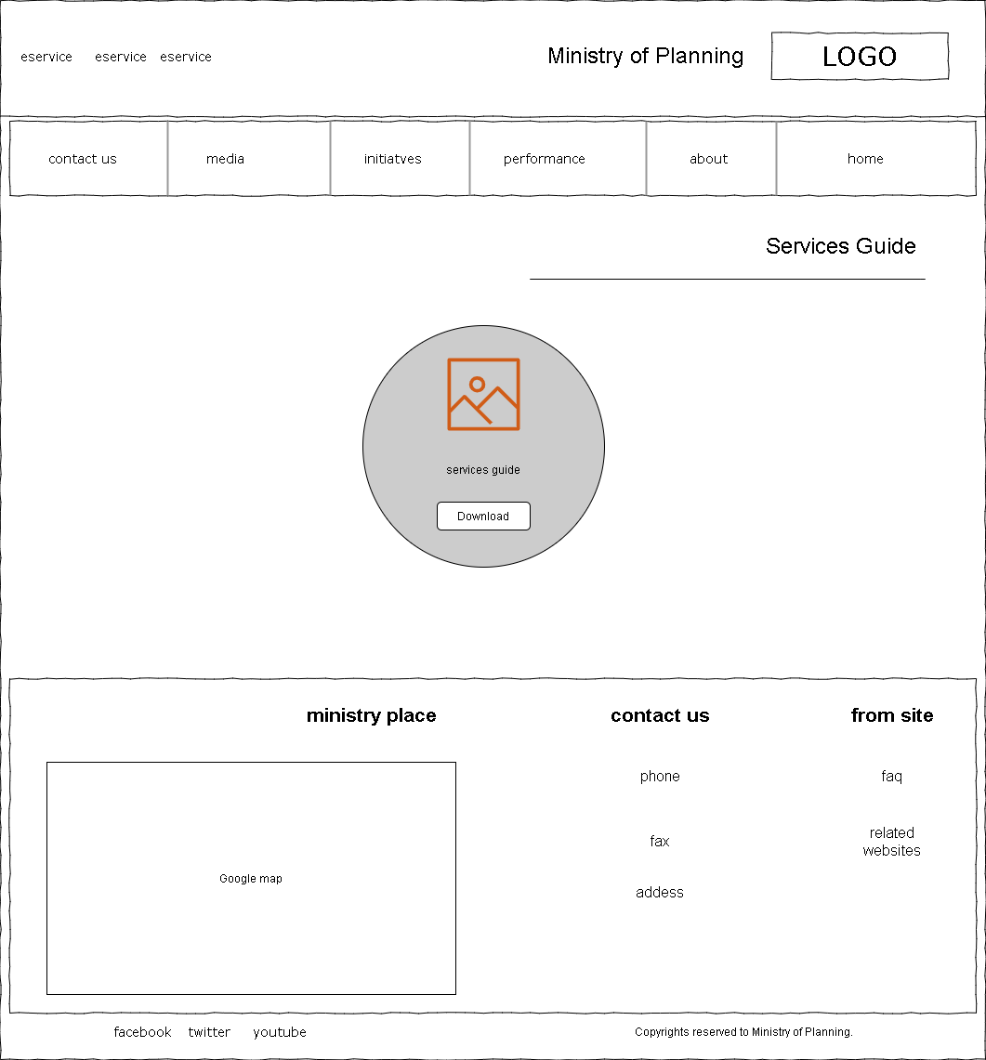

20 Services Guide-Wireframe

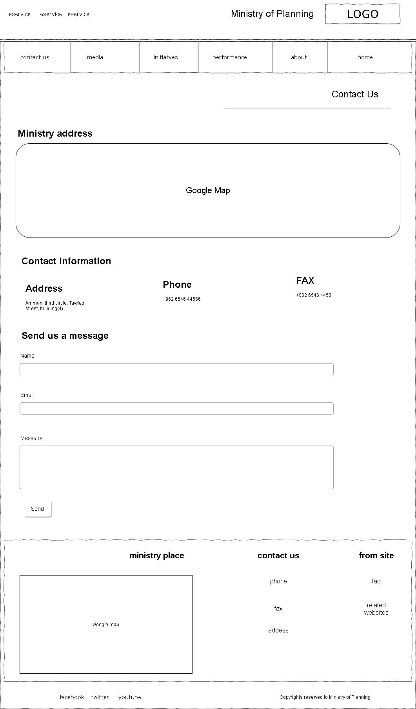

21 Contact Us-Wireframe

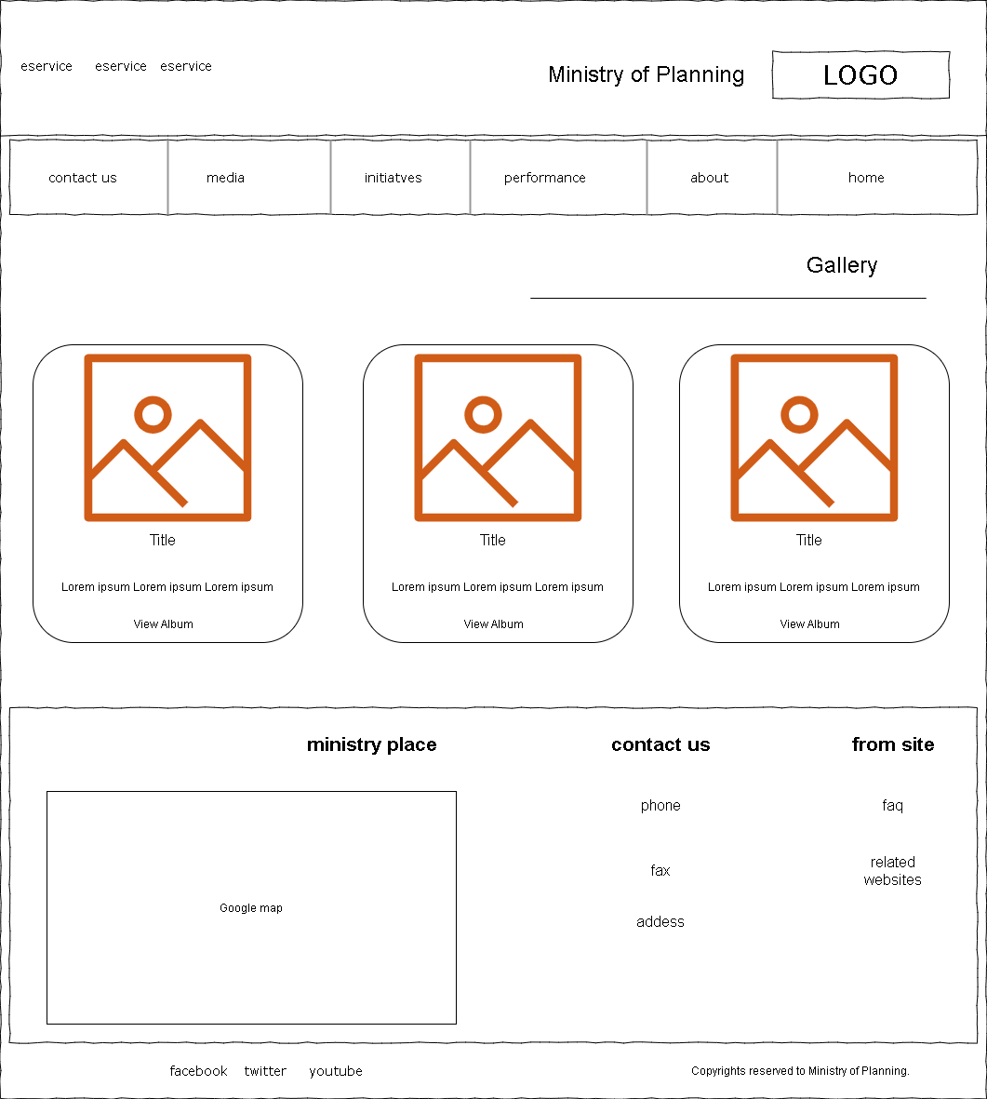

22 Gallery-Wireframe

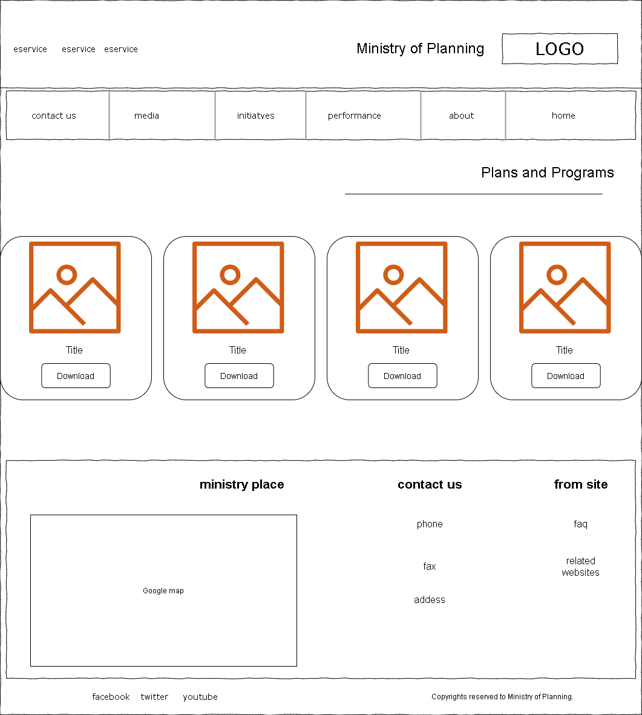

23 Plans and Programs-Wireframe

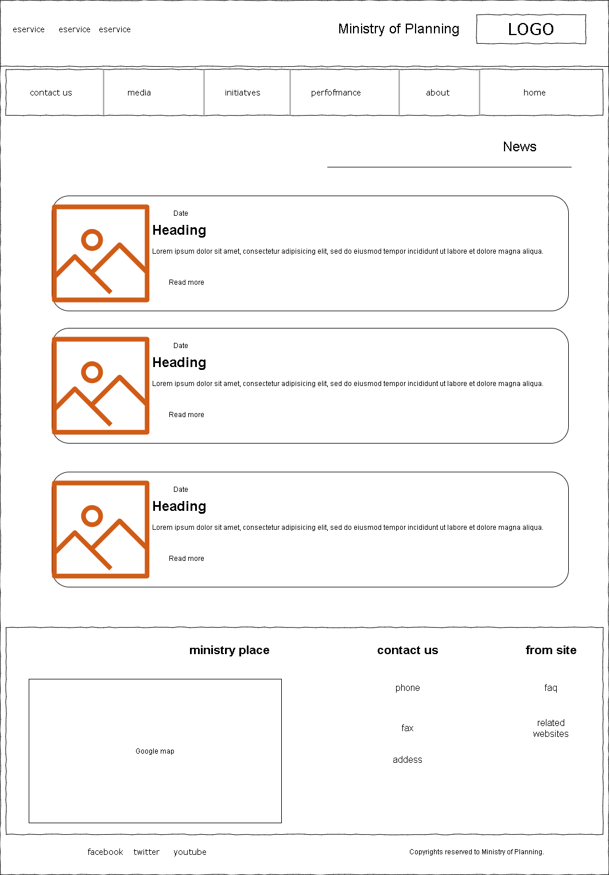

24 News-Wireframe

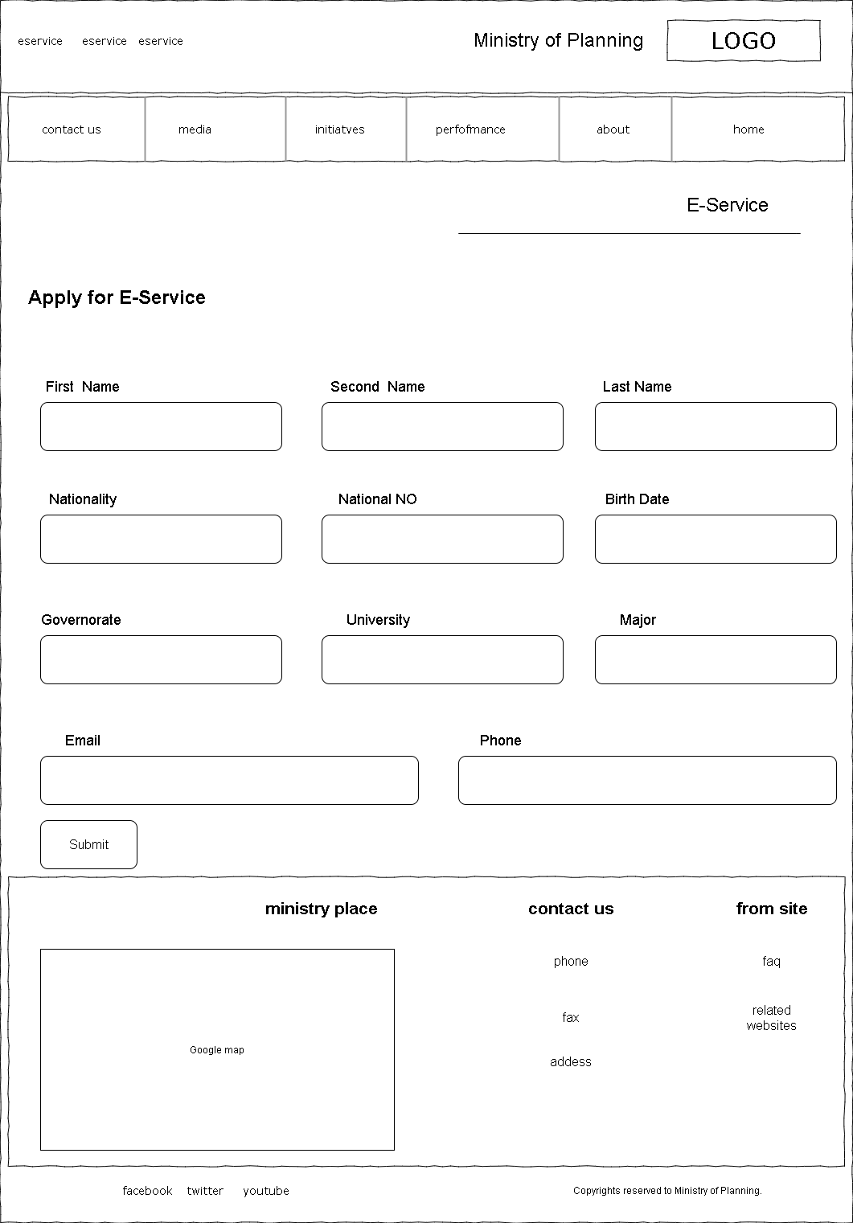

25 E-Service-Wireframe

## Mockups Screens

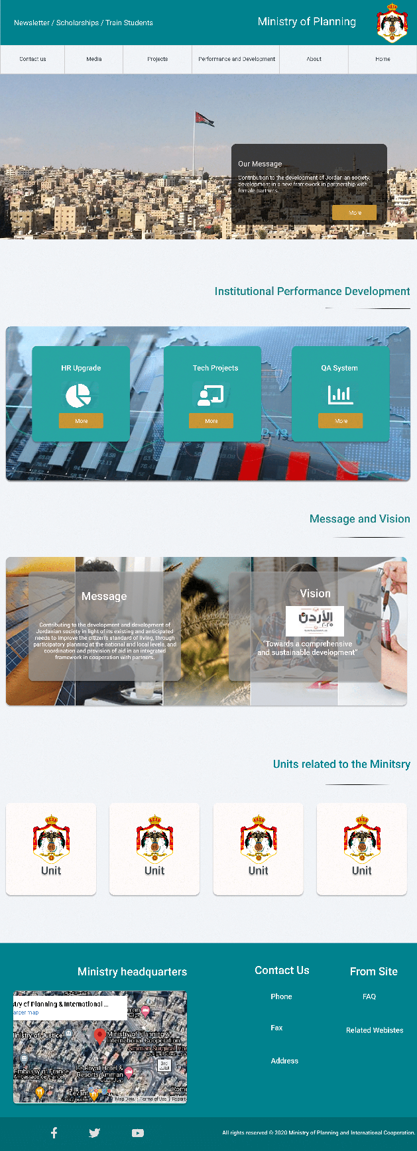

26 Homepage-Mockup

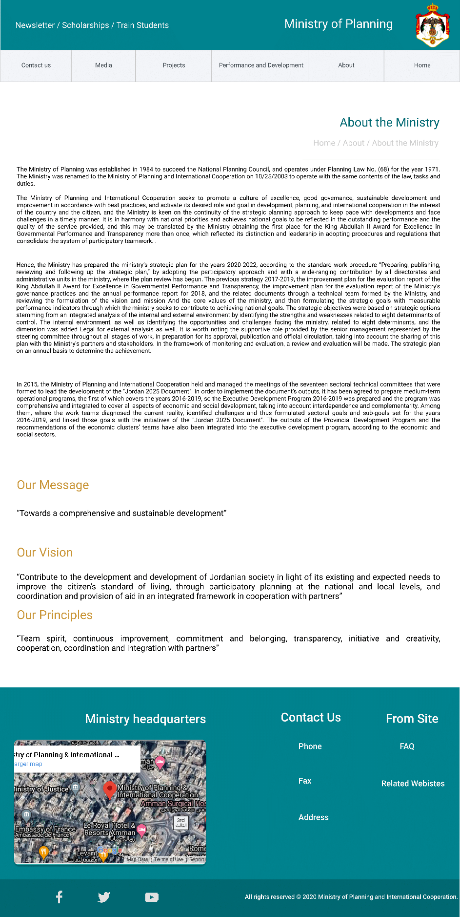

27 About-Mockup

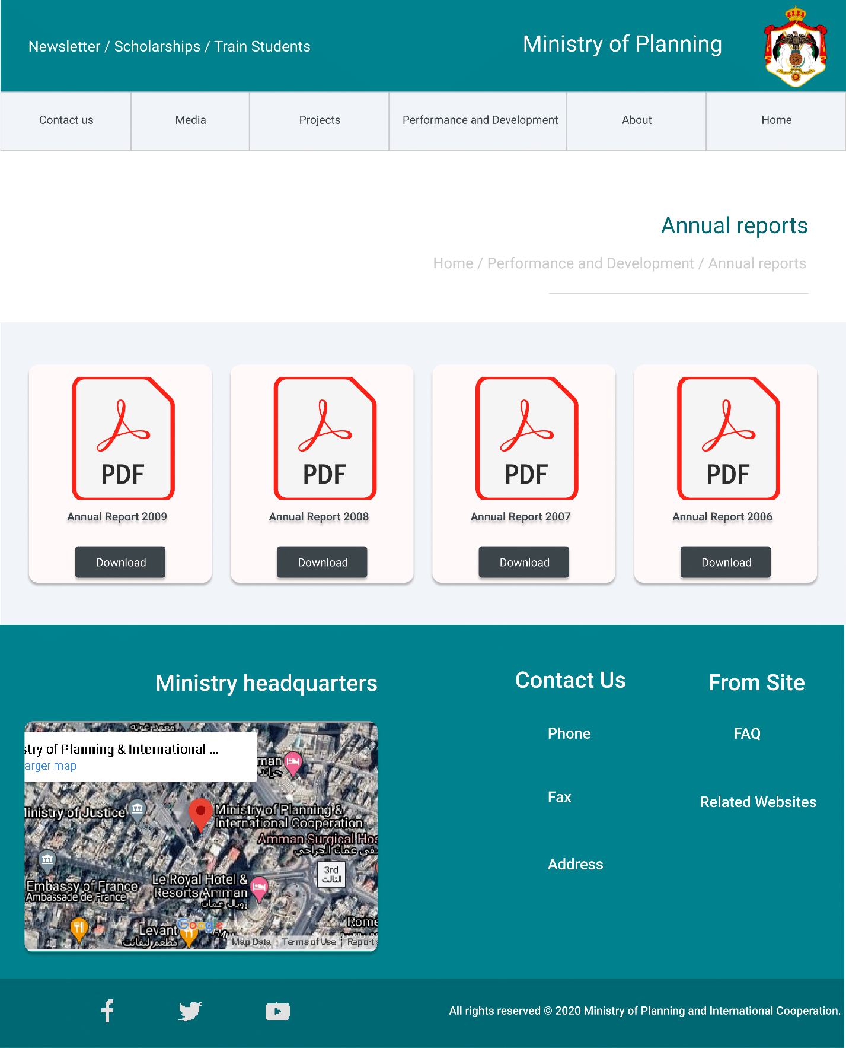

28 Annual Reports-Mockup

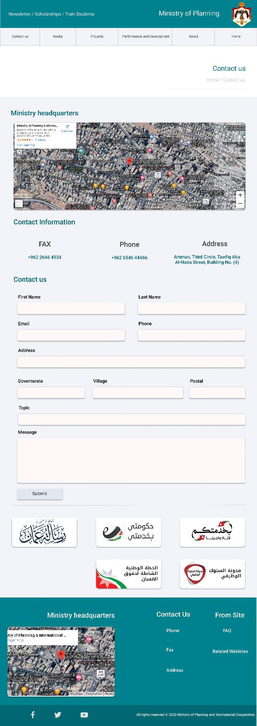

29 Contact Us-Mockup

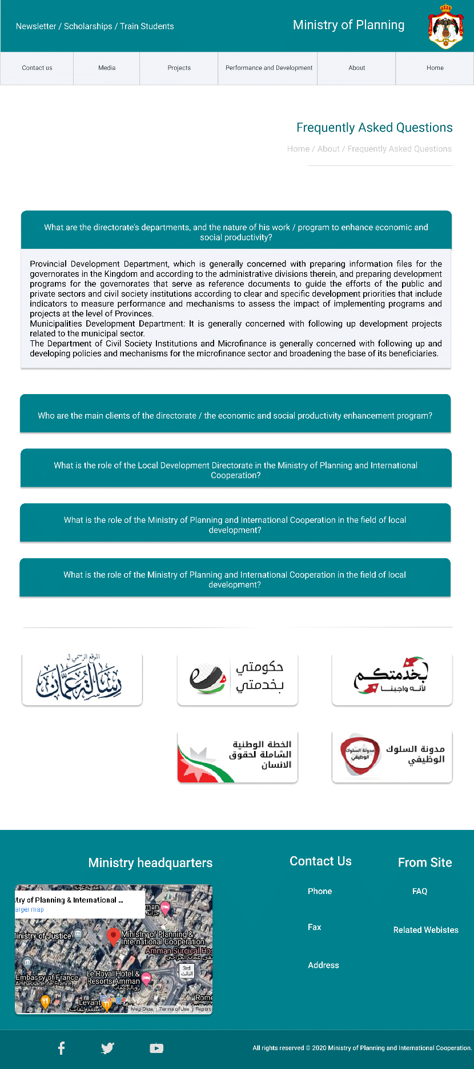

30 FAQ-Mockup

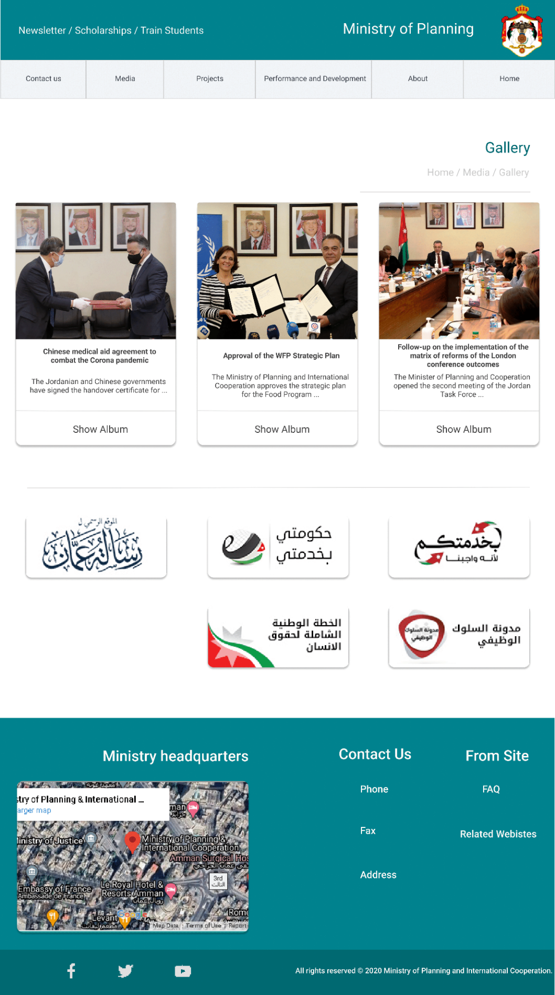

31 Gallery-Mockup

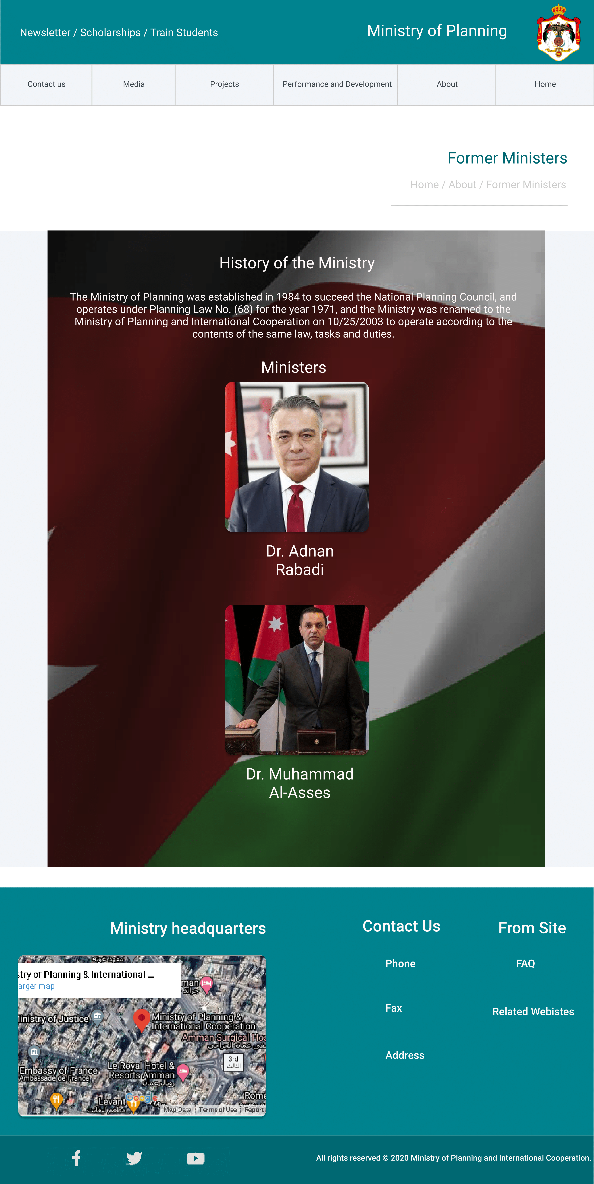

32 Ministers/General Secretaries-Mockup

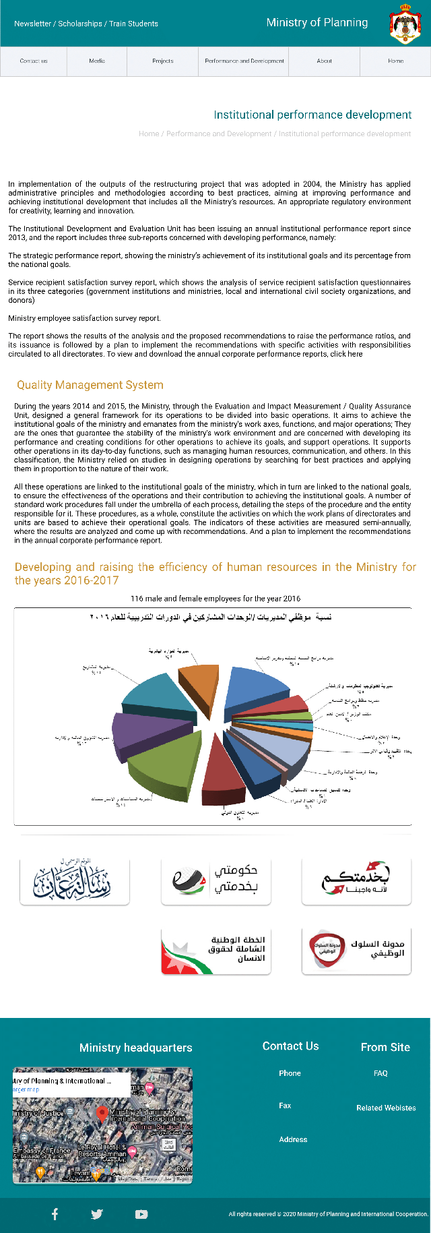

33 Performance Development-Mockup

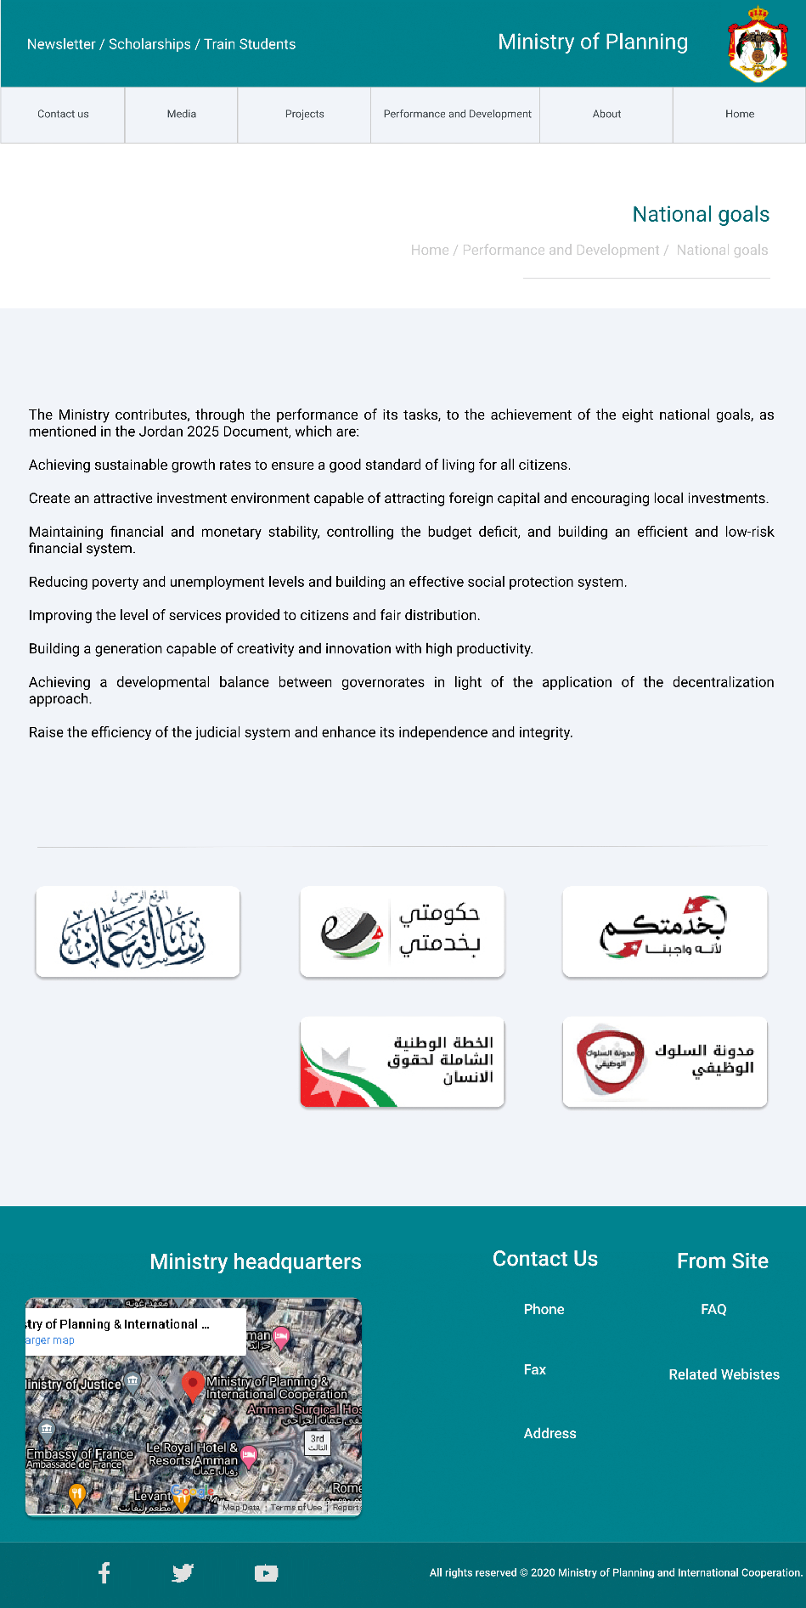

34 National Goals-Mockup

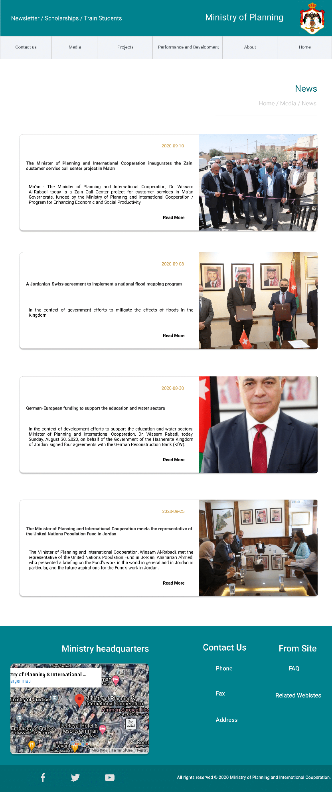

35 News-Mockup

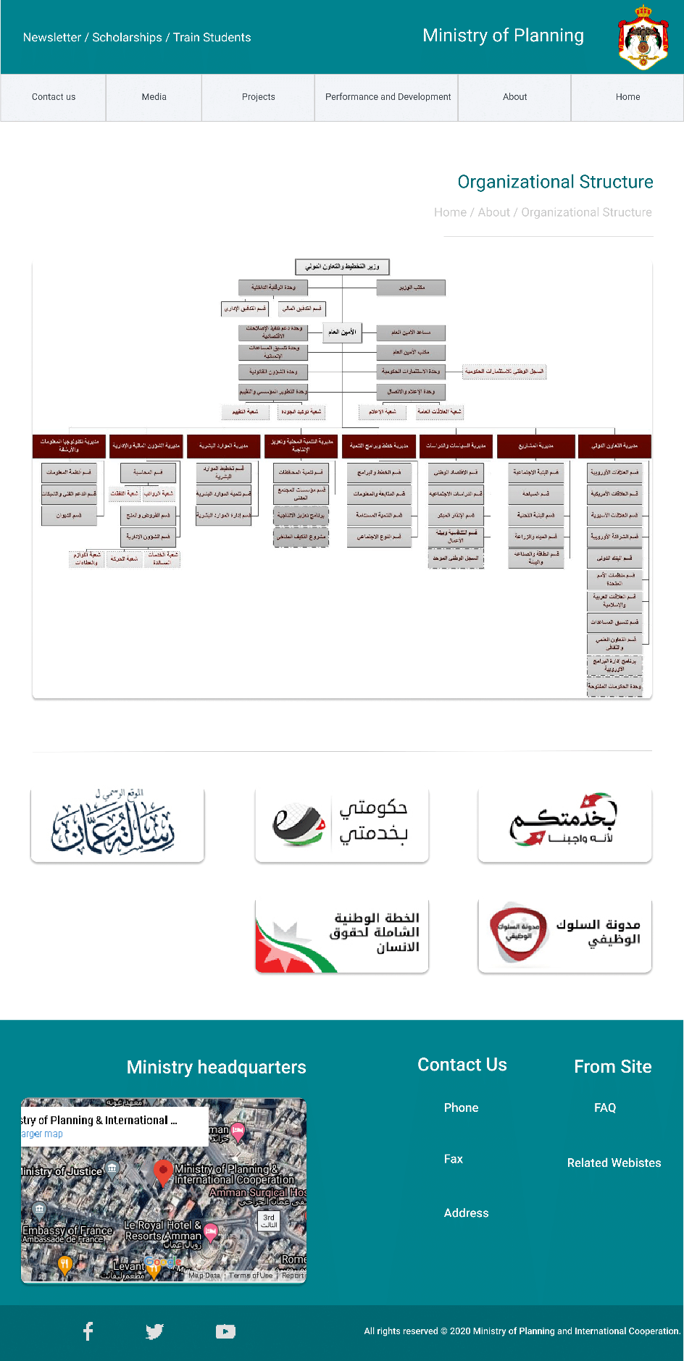

36 Organizational Chart/Strategical Plan-Mockup

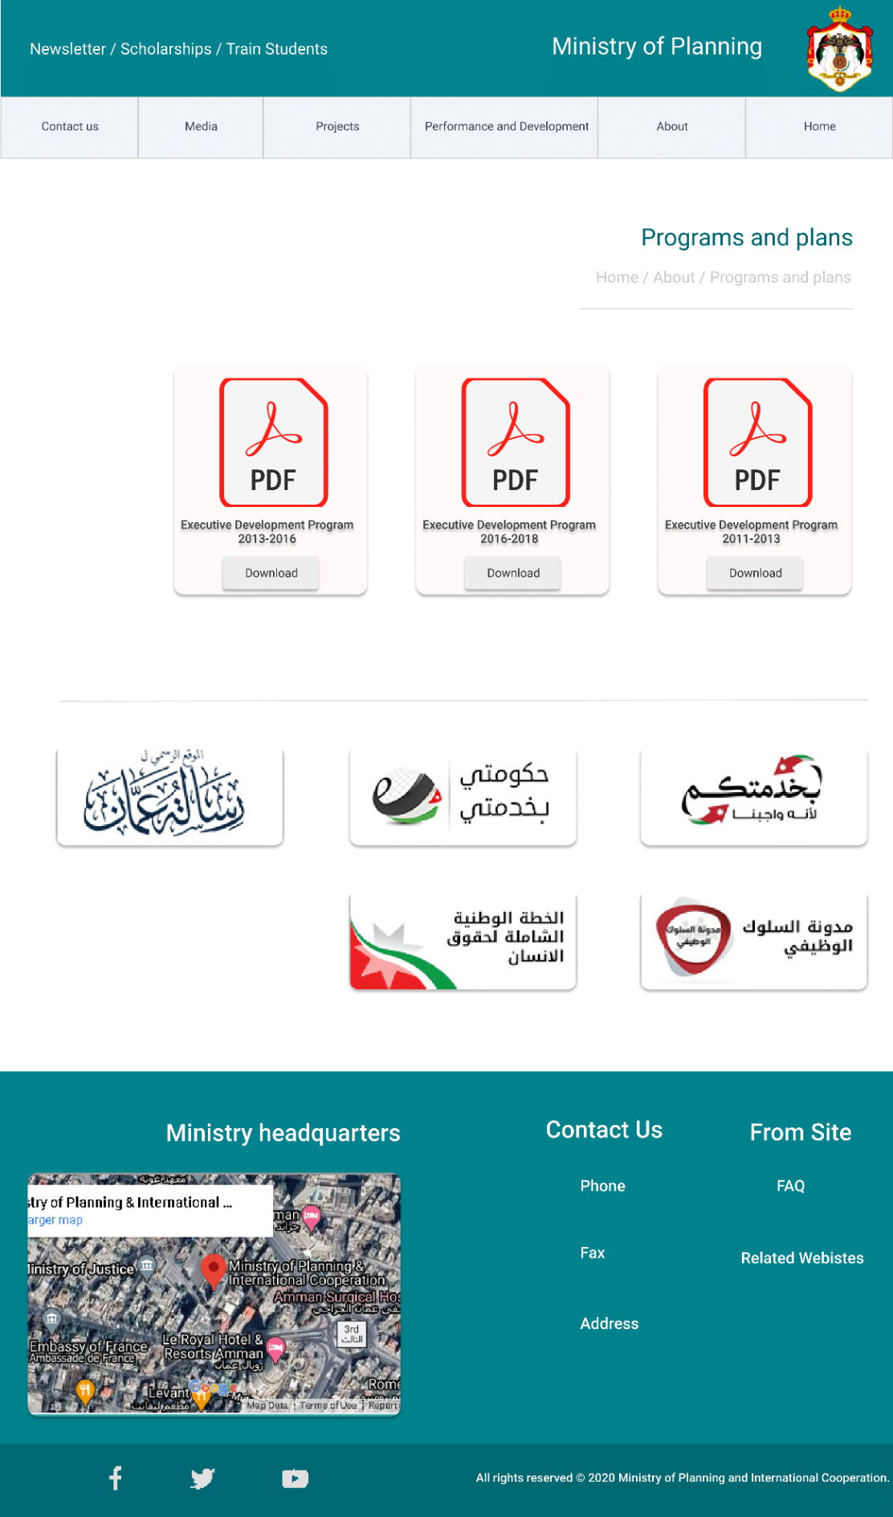

37 Plans and Programs-Mockup

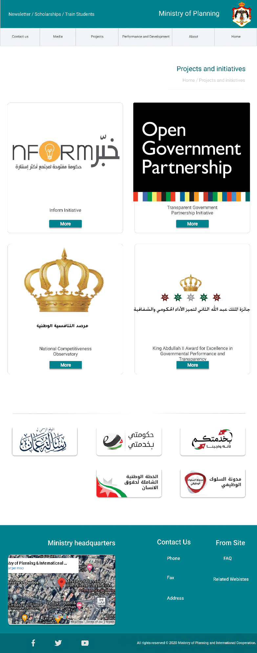

38 Projects and Initiatives-Mockup

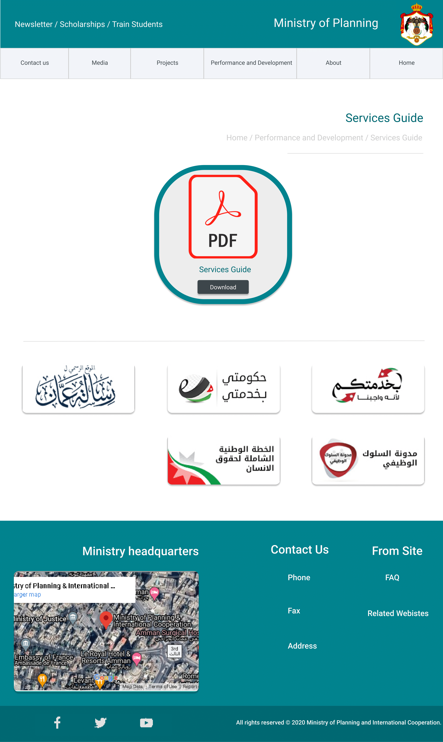

39 Services Guide-Mockup

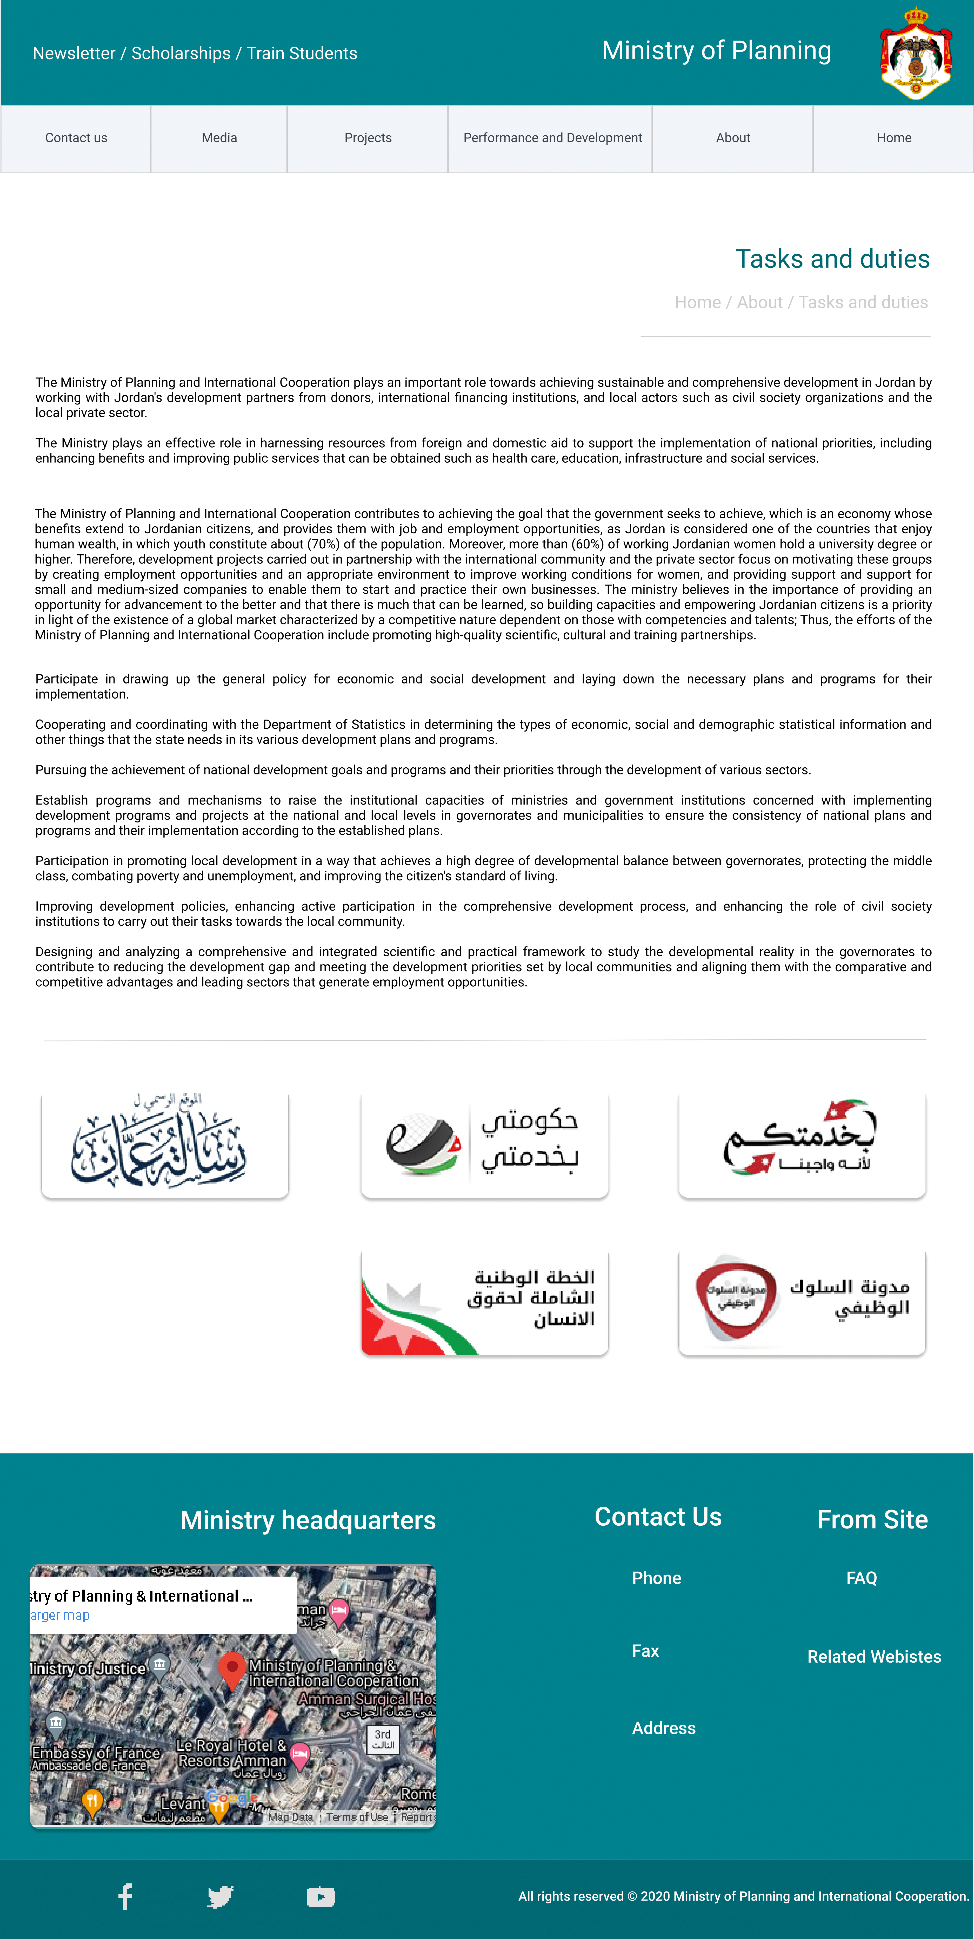

40 Tasks and Duties-Mockup

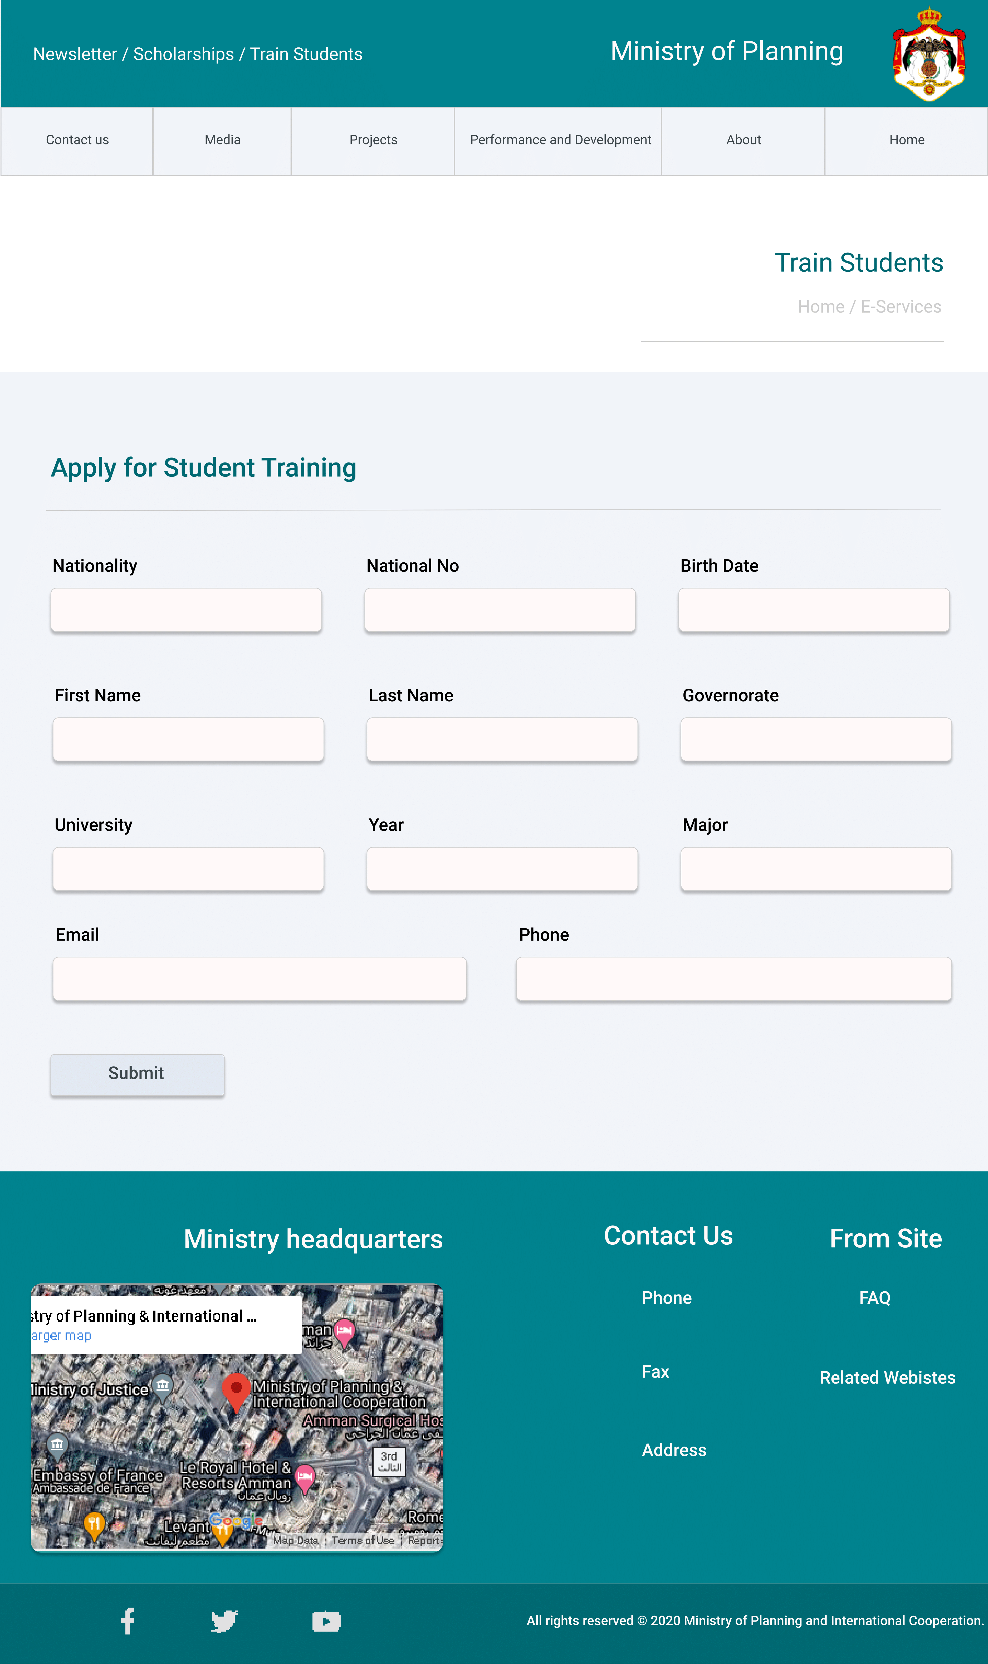

41 Train Students/ Scholarships-Mockup

## Prototypes Screens

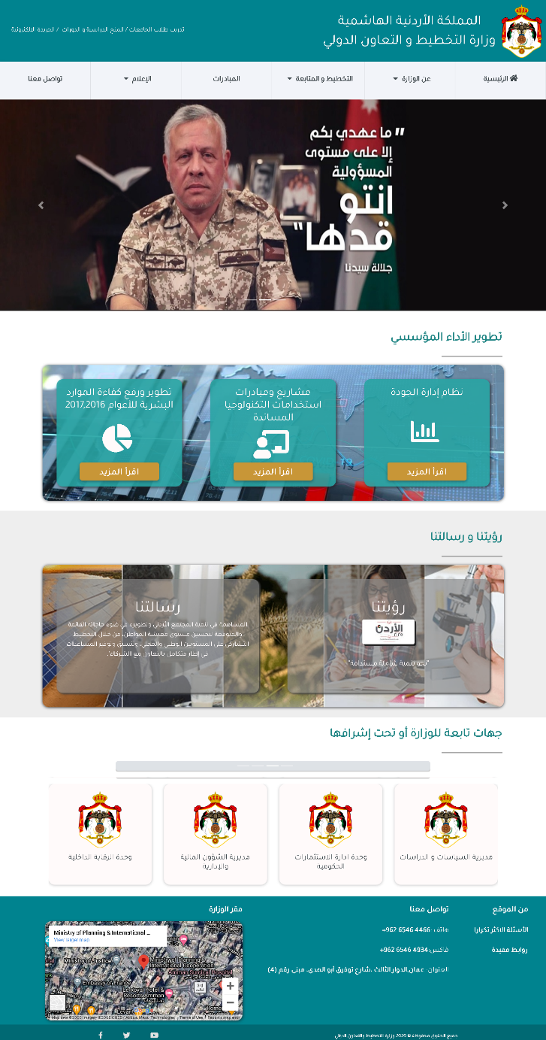

42 Homepage

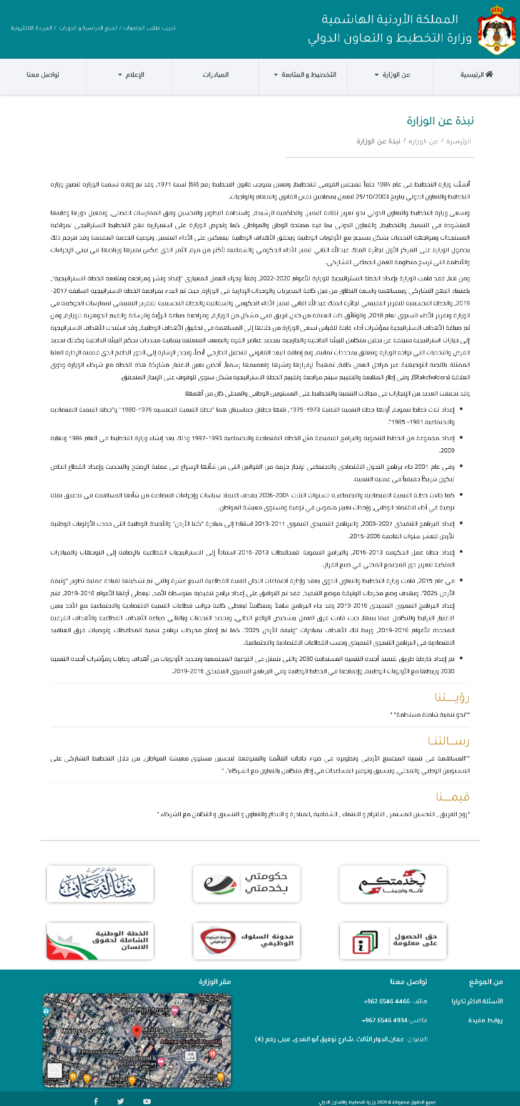

43 About

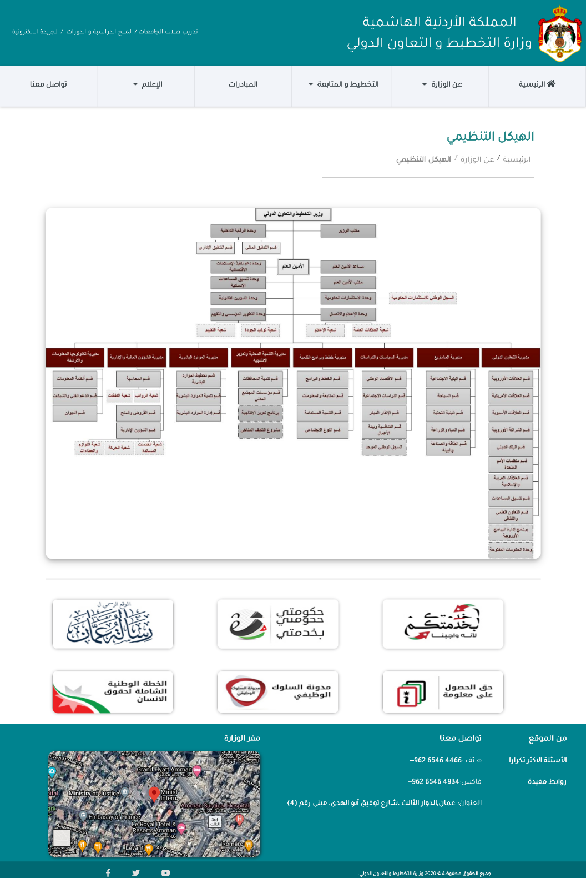

44 Organizational Chart, Strategical Plan (same page, different data)

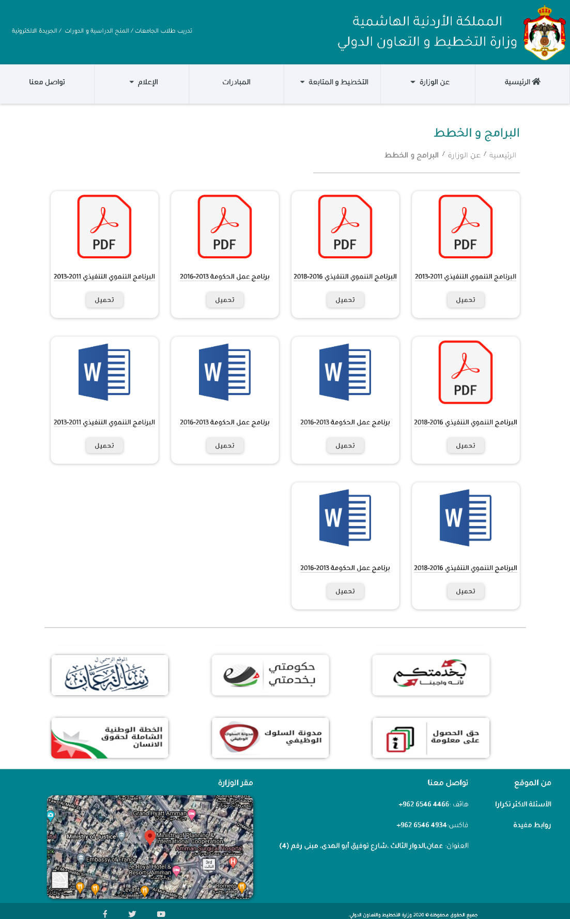

45 Plans and Programs

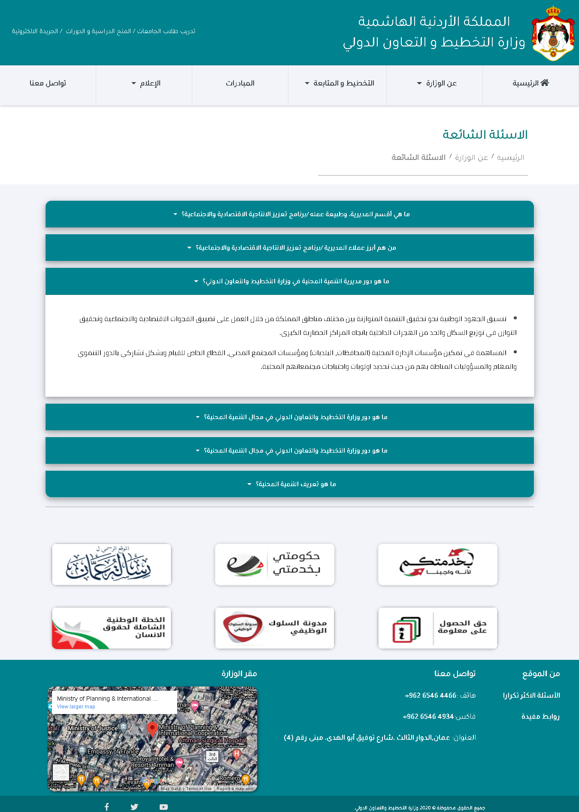

46 FAQ

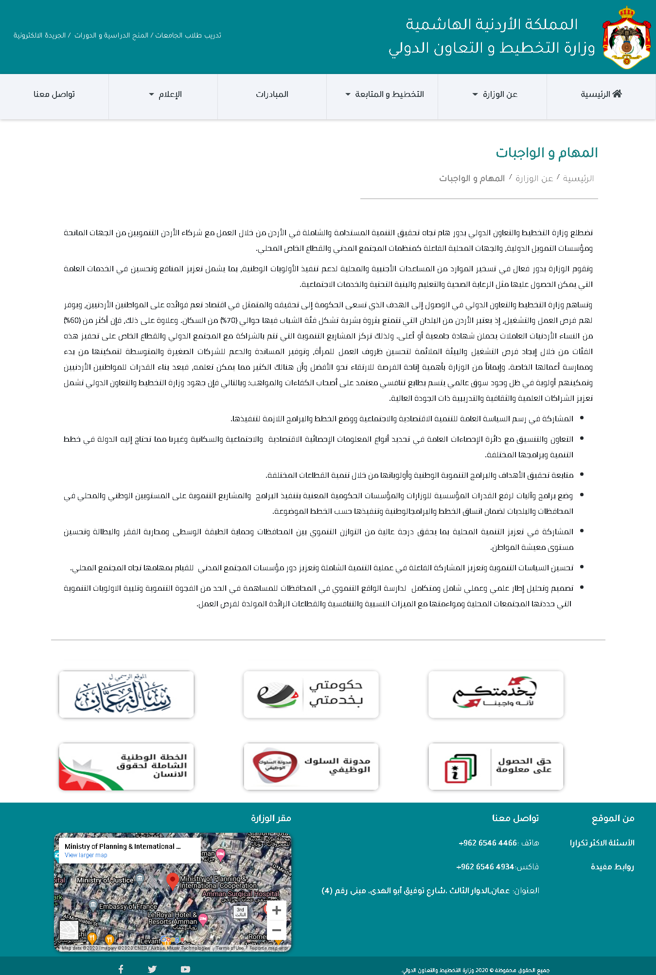

47 Tasks and Duties

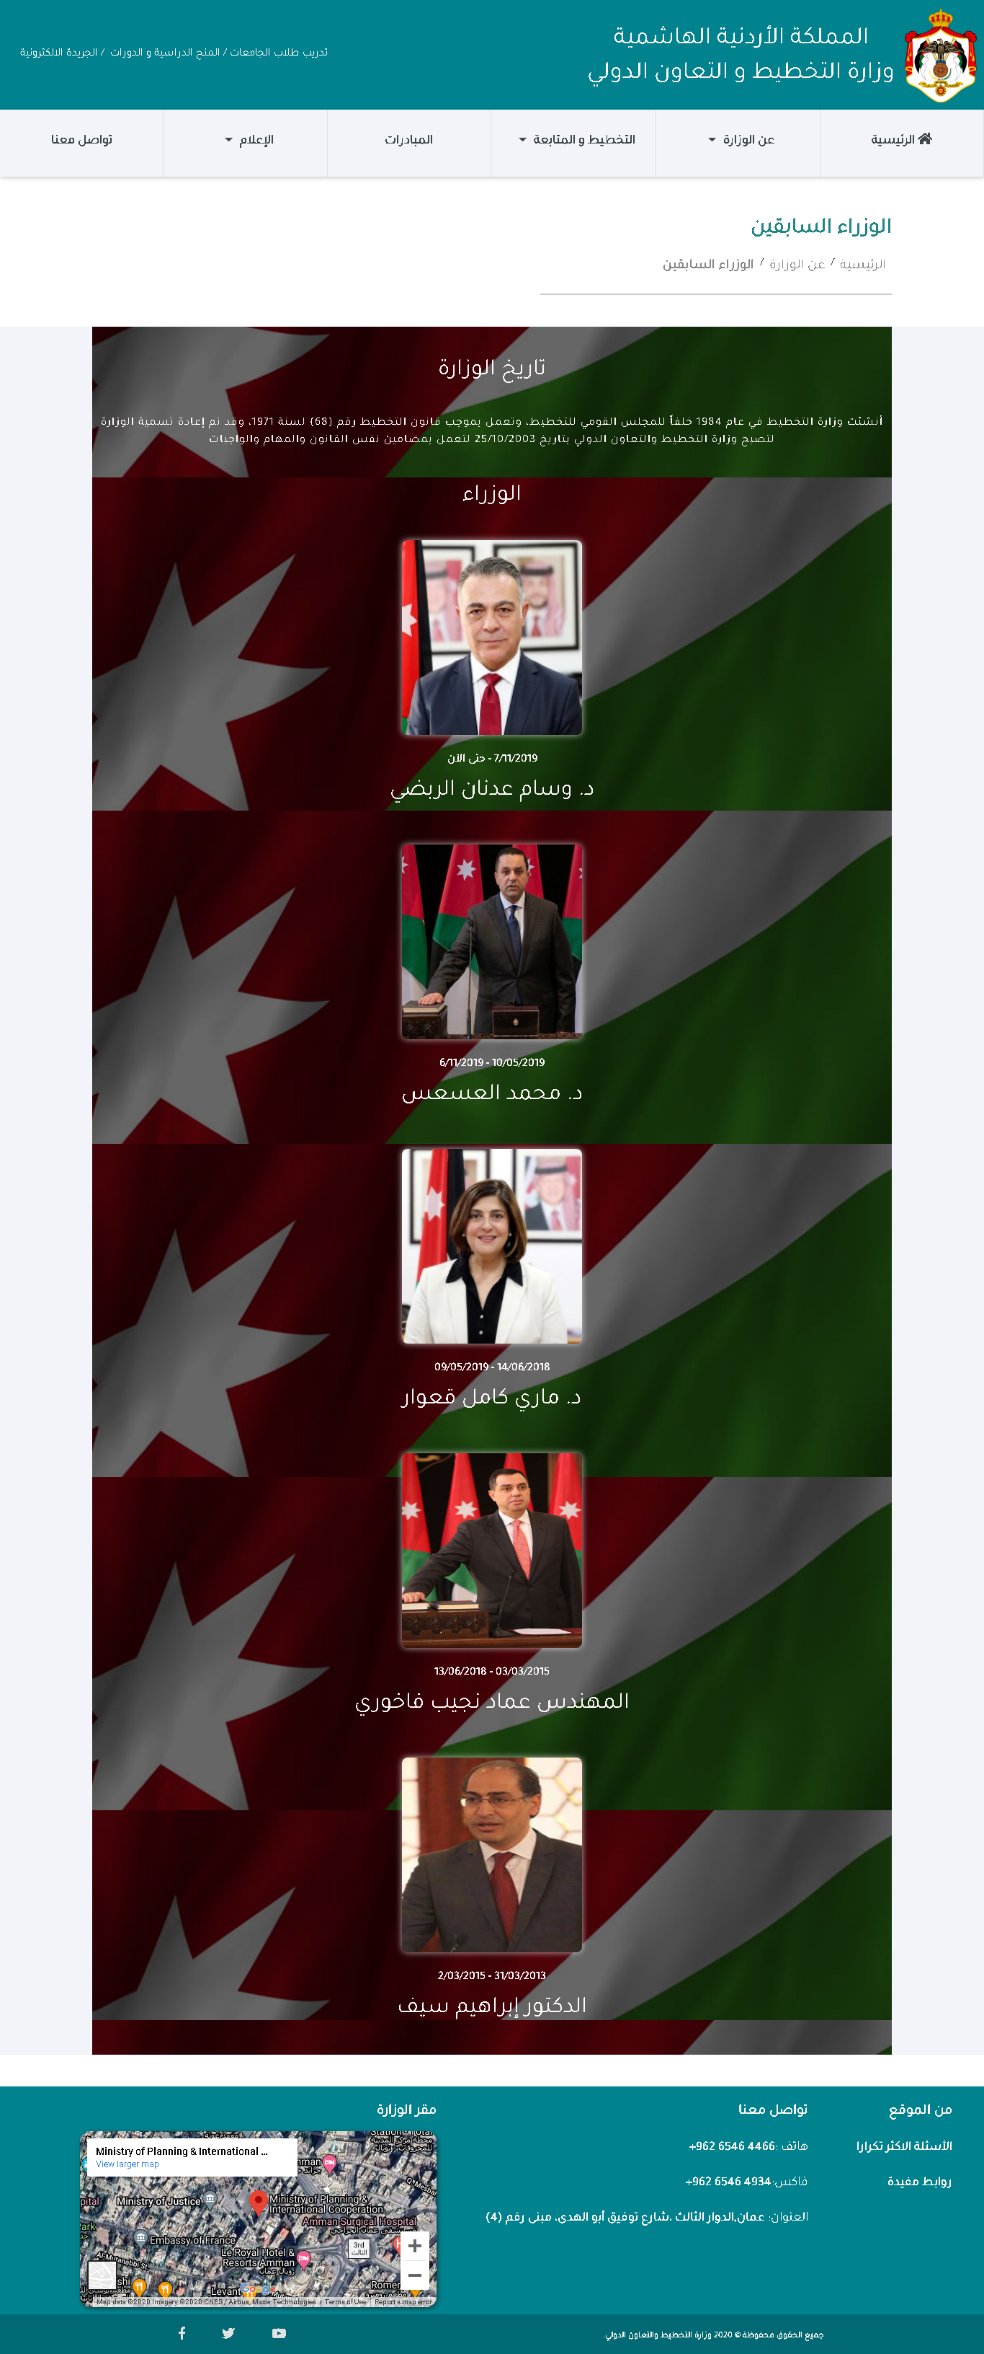

48 Ministers, General Secretaries (same page, different data) “background is ruined because of full screen screenshot”.

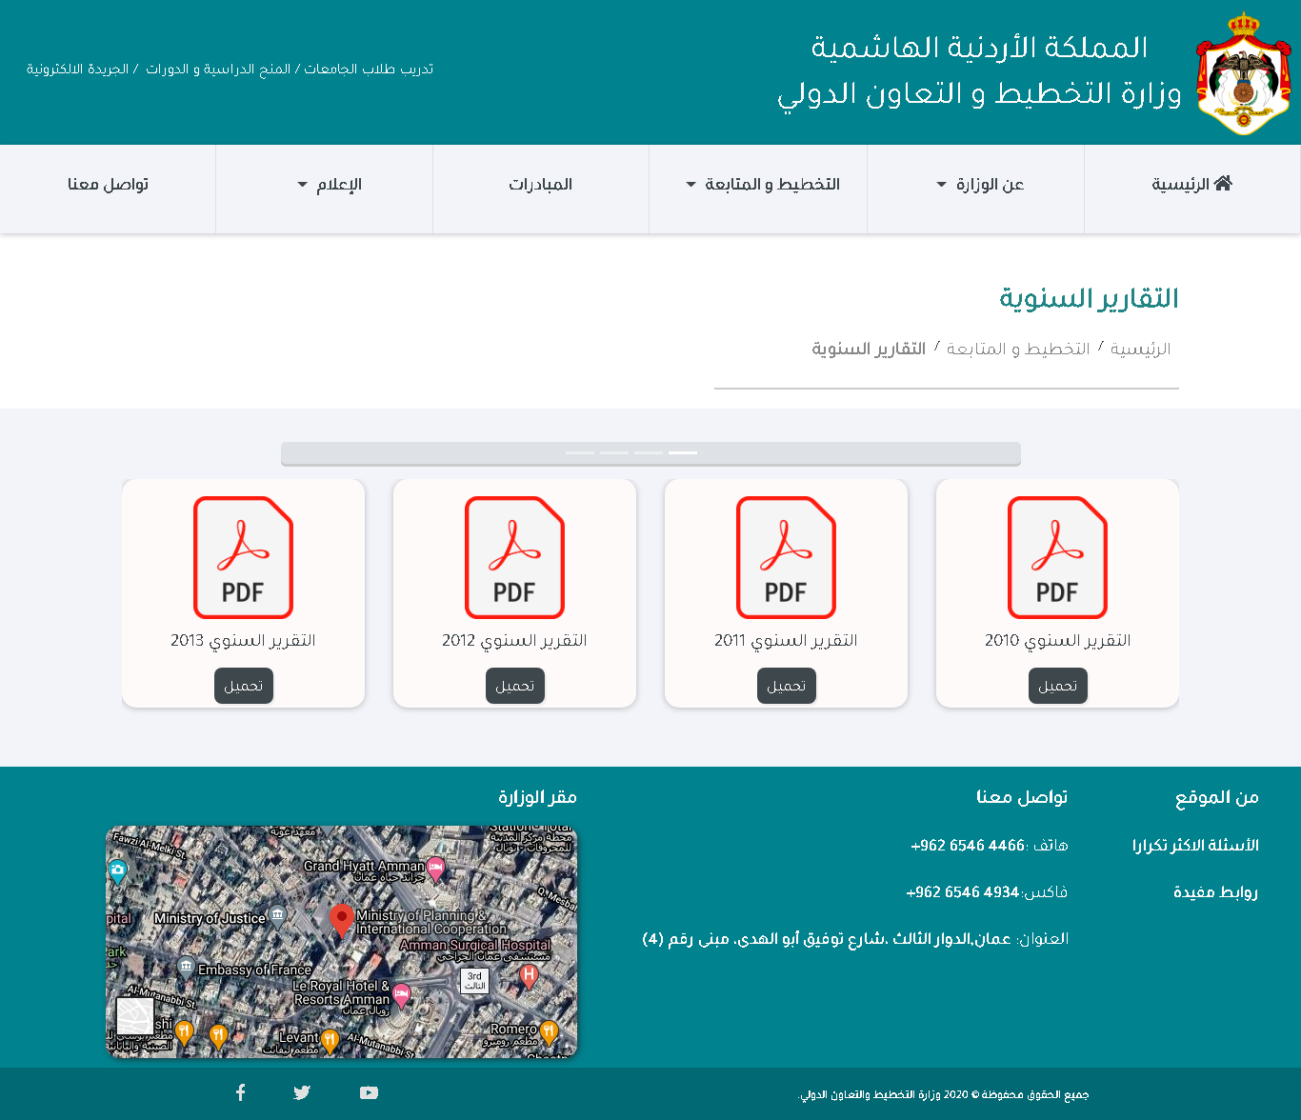

49 Annual Reports

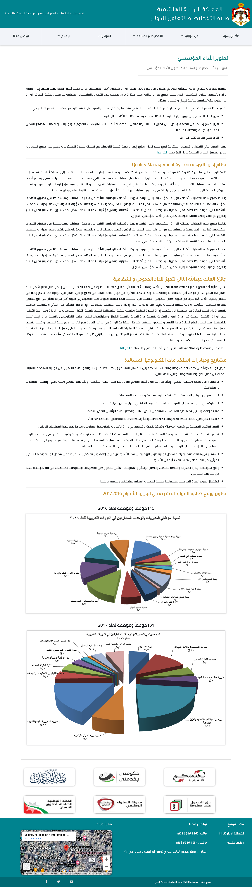

50 Performance of Development

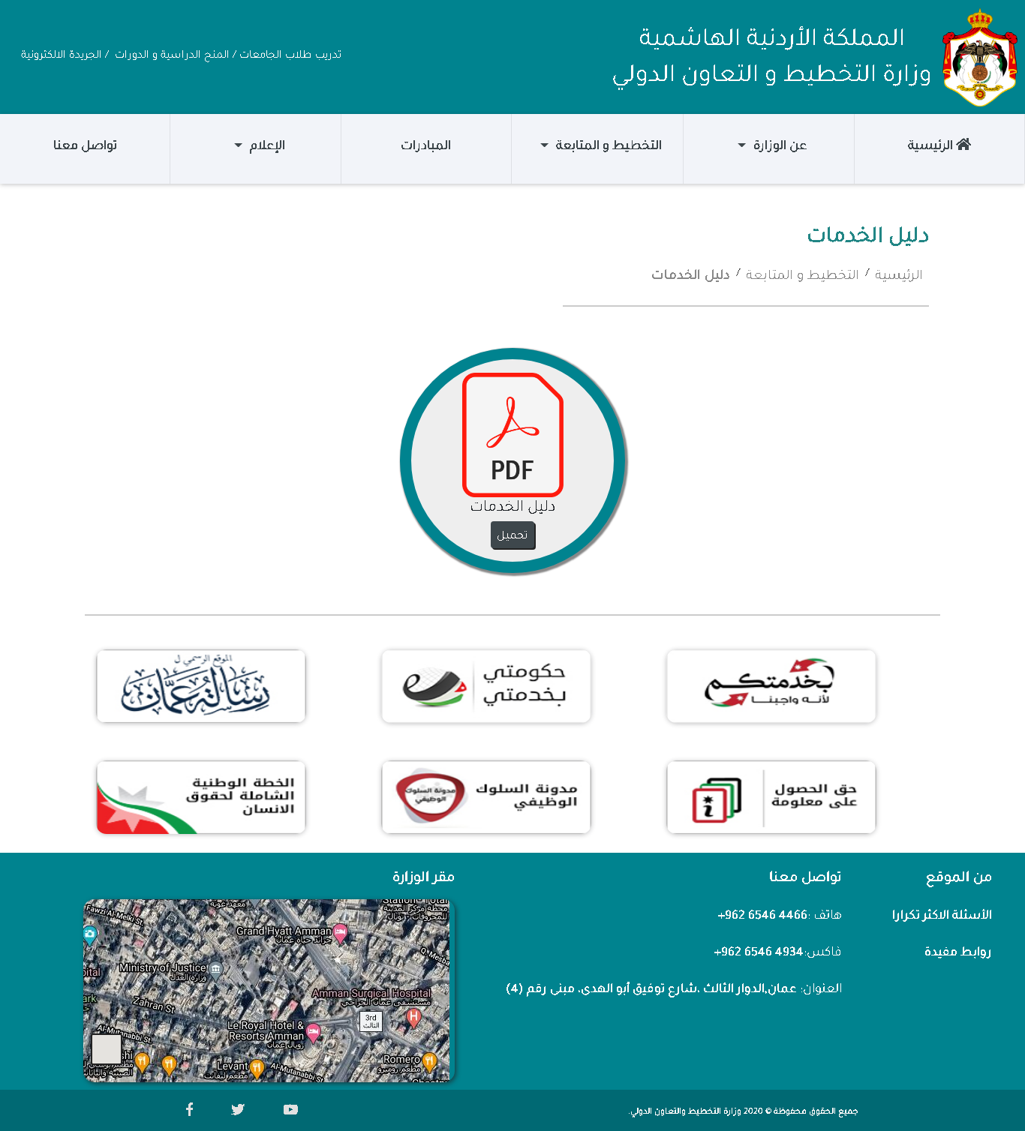

51 Services Guide

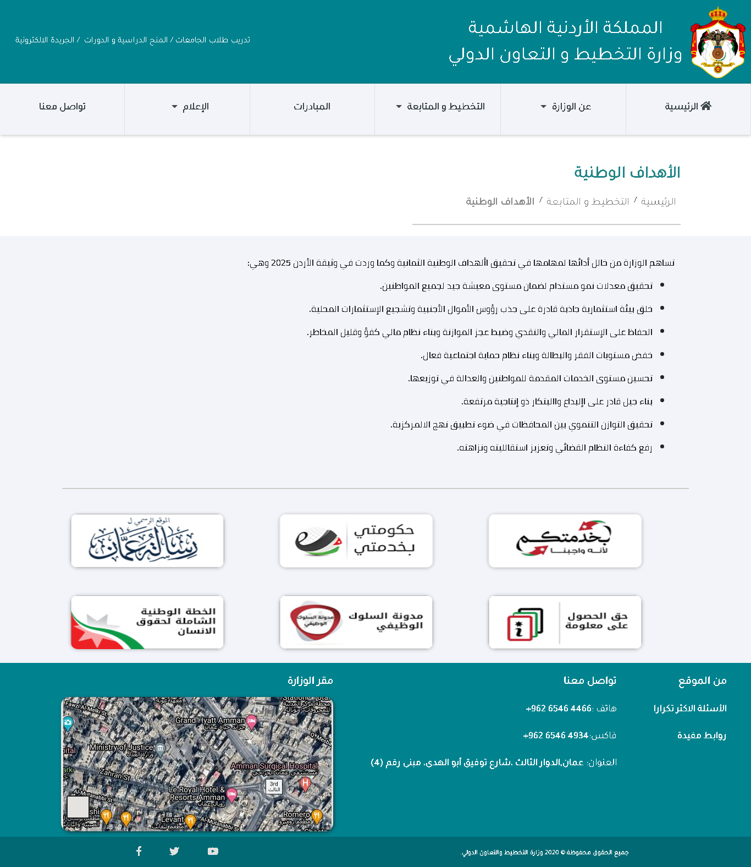

52 National Goals

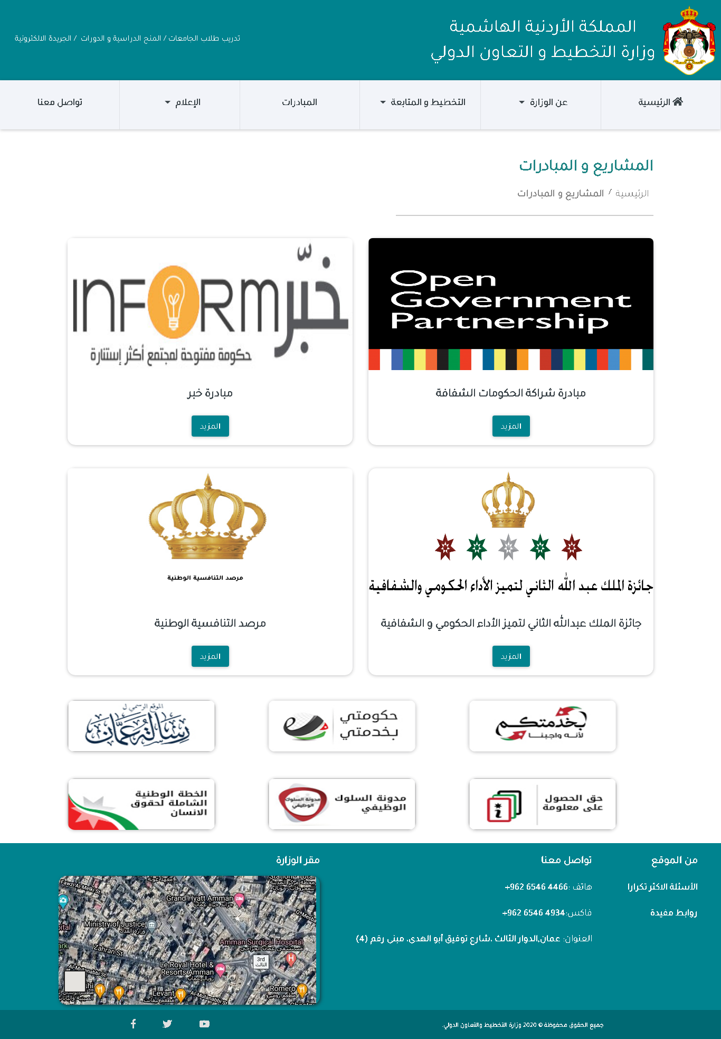

53 Projects and Initiatives

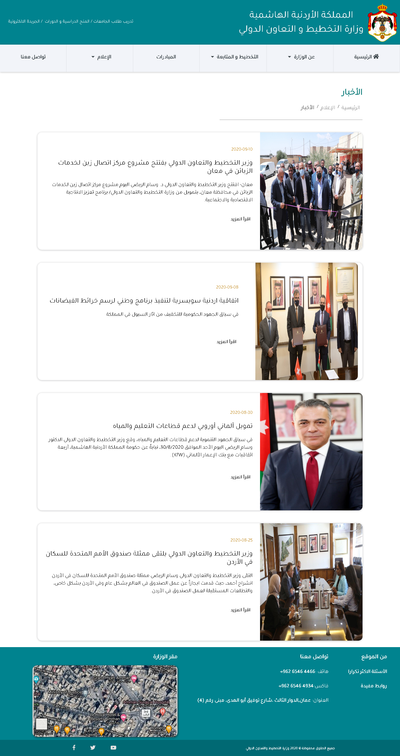

54 News

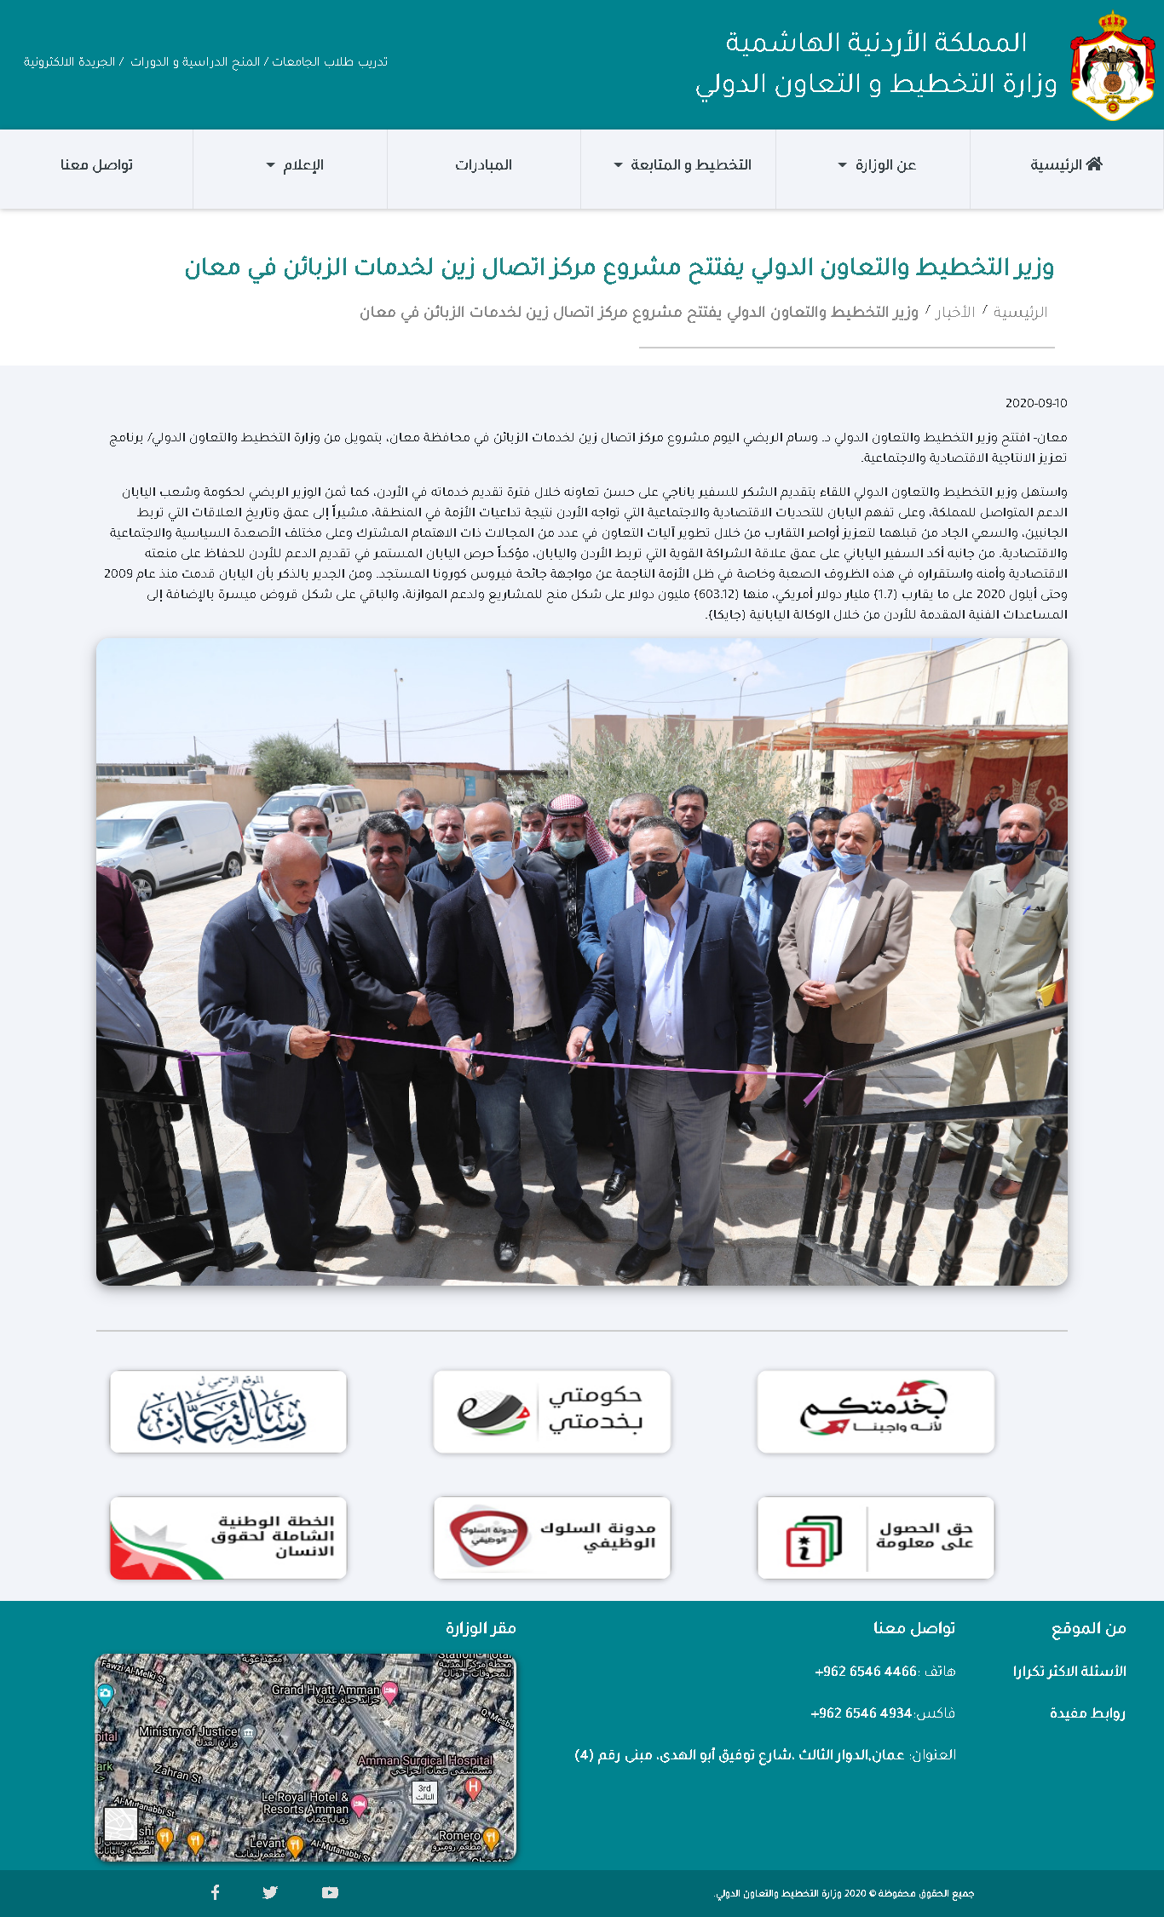

55 News Article

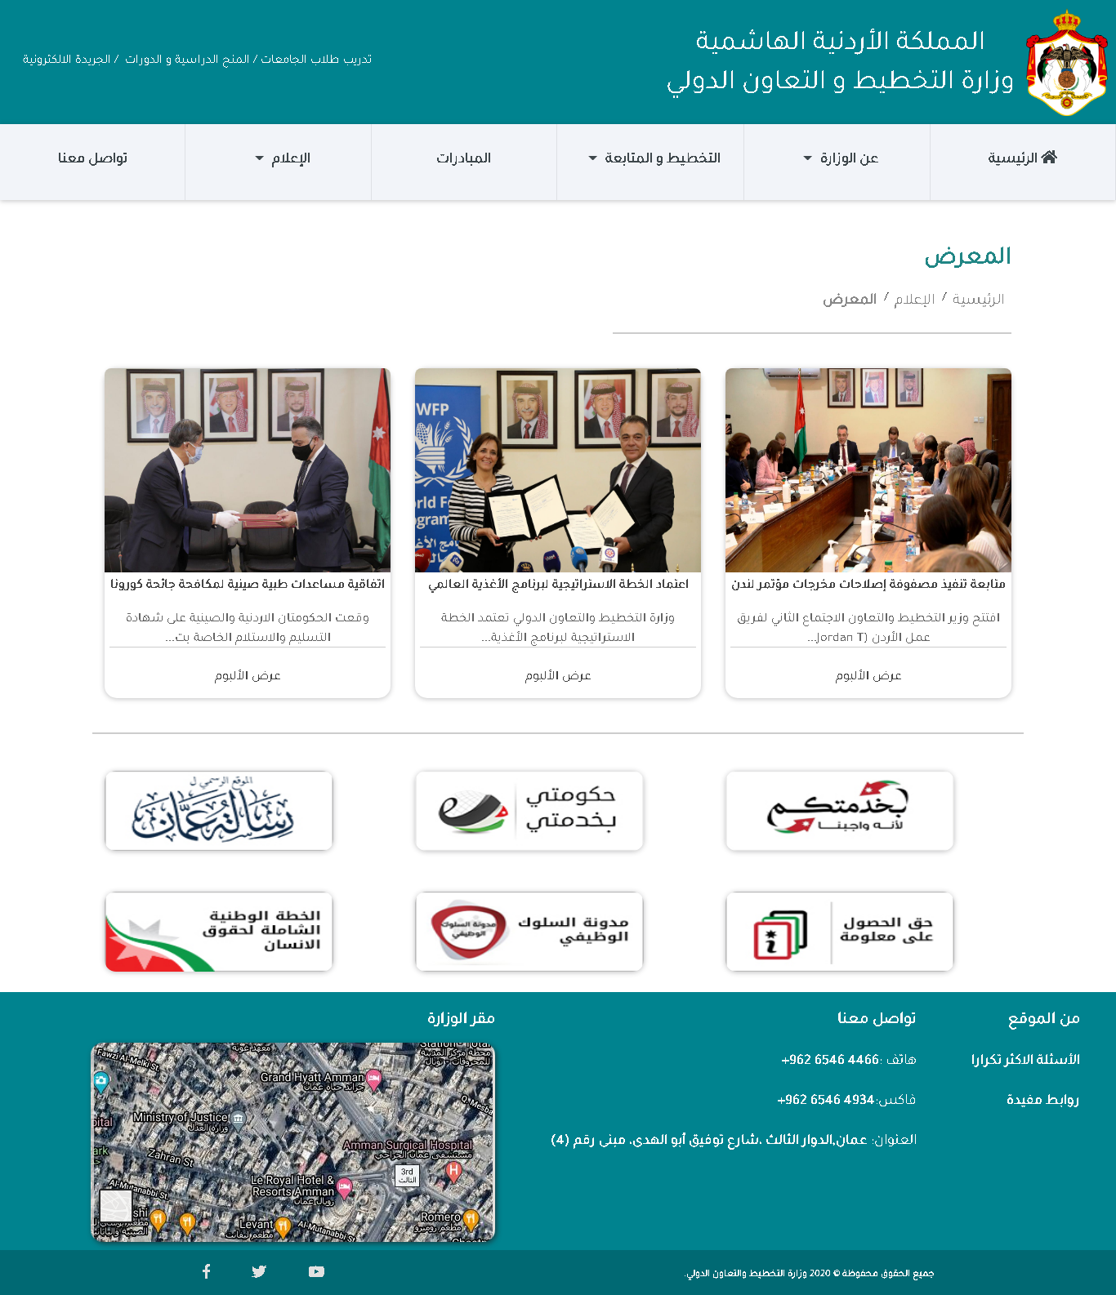

56 Gallery

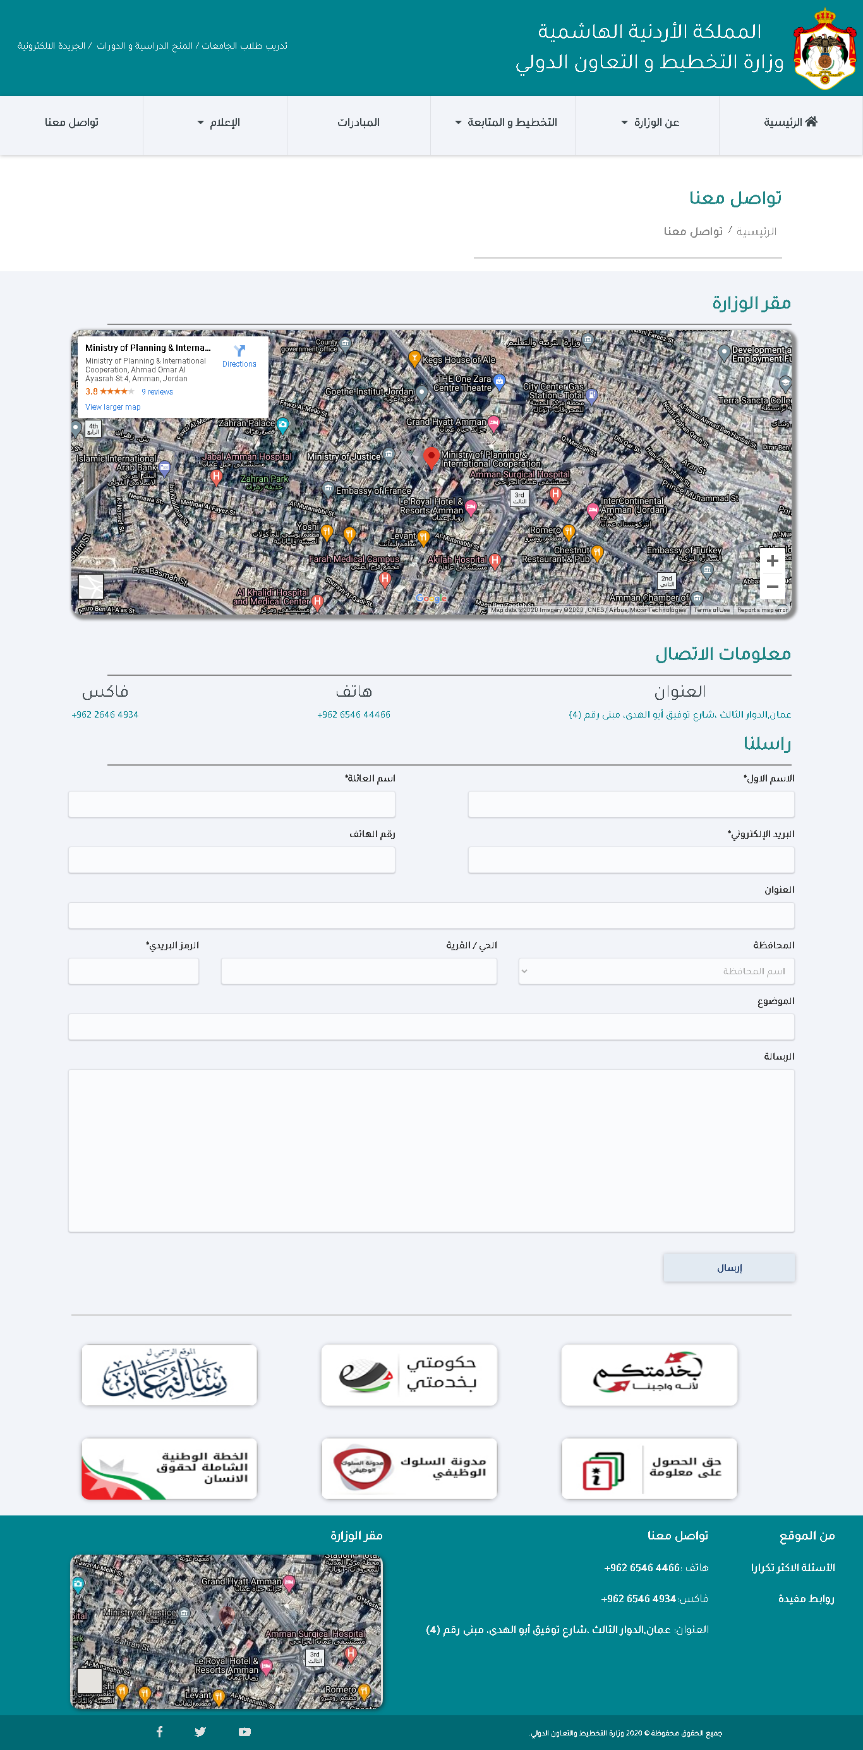

57 Contact Us

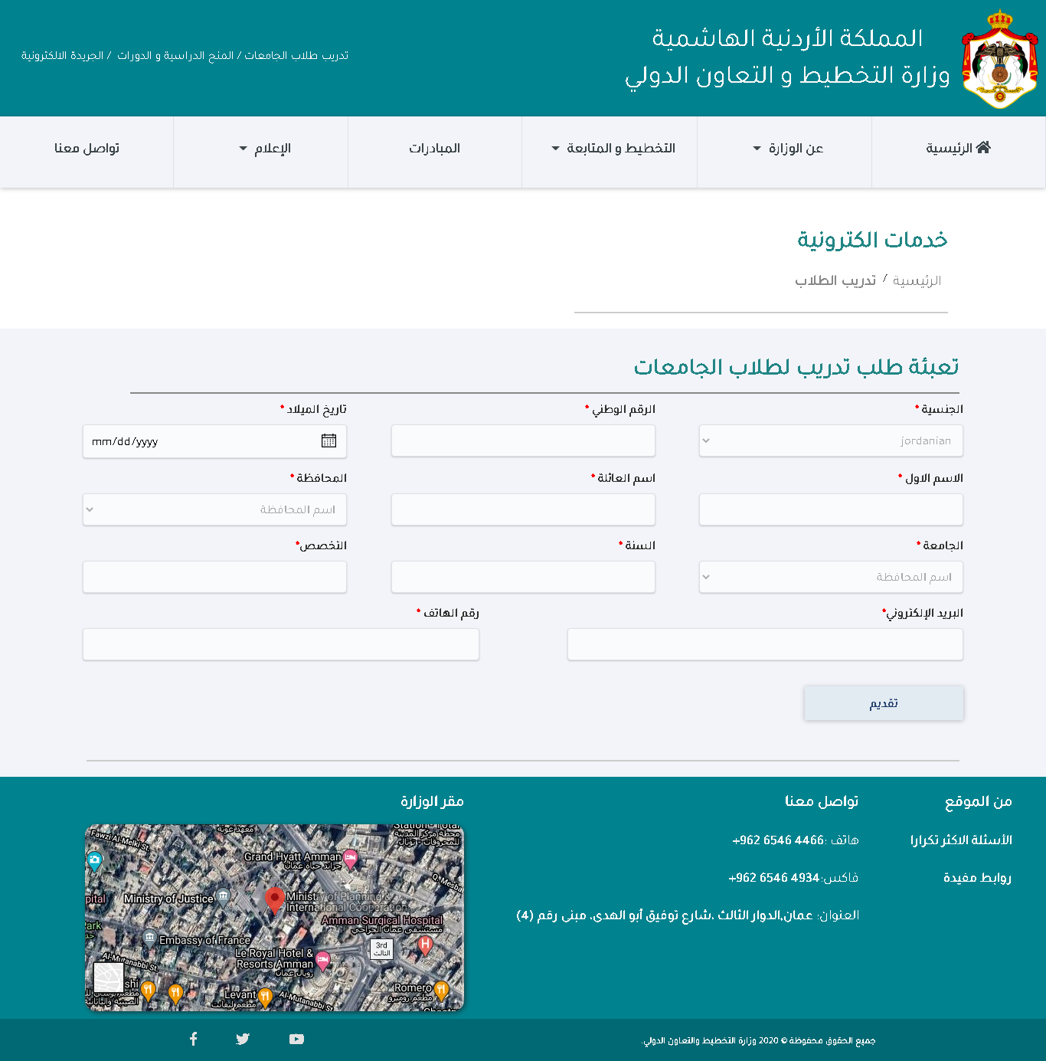

58 E-services pages all look the same

# Source Code excerpts

Below is a snippet from the server. The first part is setting up the template engine and assigning the default layout to the views. Also assigning the partials folder.

The second part is the server handling a get request to the homepage (index page). Inside of it there is a query that selects all the data from min_units table to dynamically render units on the homepage.

**app.engine('hbs', handlebars({**

**layoutsDir: __dirname + '/views/layouts',**

**extname: 'hbs',**

**//new configuration parameter**

**defaultLayout: 'index',**

**partialsDir: __dirname + '/views/partials/'**

**}));**

**// root**

**app.get('/', (req, res) => {**

**console.log(req.url);**

**con.query(`select * from min_units;`, (err, rows) => {**

**if (err)**

**res.render('main', { title: 'الصفحة الرئيسية' });**

**else {**

**var resultArray = JSON.parse(JSON.stringify(rows));**

**const indxesForArr = Math.ceil(resultArray.length / 4);**

**const indxesArray = [];**

**for (let index = 0; index < resultArray.length; index += 4) {**

**let minArr = resultArray.slice(index, index + 4);**

**let obj = { units: minArr };**

**indxesArray.push(obj);**

**console.log(minArr)**

**}**

**for (let index = 0; index < indxesForArr; index++) {**

**indxesArray[index]['index'] = index;**

**}**

**console.log(indxesArray);**

**res.render('main', { title: 'الصفحة الرئيسية', ir: indxesArray });**

**}**

**});**

**});**

Here is how it is rendered in the main page using Handlebars helpers.(each, first, index, if)

**<section class="section">**

**<h3>جهات تابعة للوزارة أو تحت إشرافها</h3>**

**<!-- slider for units -->**

**<div class="container">**

**<div id="carouselExampleSlidesOnly" class="carousel slide" data-ride="carousel">**

**<ol class="carousel-indicators indi">**

**{{#each ir}}**

**<li data-target="#carouselExampleSlidesOnly" data-slide-to="{{@index}}" class="{{#if @first}}active{{/if}}"></li>**

**{{/each}}**

**</ol>**

**<div class="carousel-inner">**

**{{#each ir}}**

**<div class="carousel-item {{#if @first}}active{{/if}}">**

**<div class="row">**

**{{#each [units]}}**

**<div class="col-3">**

**<a href="/unit?id={{this.unit_id}}" class="unita">**

**<div class="unit">**

**<img src="crown.png" alt="">**

**<h5> {{this.unit_name}}</h5>**

**</div>**

**</a>**

**</div>**

**{{/each}}**

**</div>**

**</div>**

**{{/each}}**

**</div>**

**</div>**

**<!-- end of slider for units -->**

**</div>**

**</section>**

# Conclusion

There is no system in the world that is perfect, including mine. There is a system that has less visible issues than others. As a developer, I try to conceal these issues from the public eye until they are fixed or modified to be better. I am writing this report knowing that my system has some issues that can be modified. Even though they are not major ones, but still they are issues. I learned a lot of new things throughout this period of development, and I am quite proud of what I have done. I would use this knowledge to build future systems. One of the things I would enhance in the future is the validation part in forms. I want to make it, even more, user-friendly, better to work with for all types of users. I would add a content management system to keep the dynamic of the website at the top. I would add a news-sorting option. I would add a search to navigate throughout the website using keywords and even implement an auto-complete search like Google. I would add more detailed information about each one of the initiatives, instead of just linking them to the outworld. I would enhance the e-services, even more, to be able to serve different nationalities. I would like to make the website available in the English language. I would add more e-services and focus them on developing young generations and convert them to an active member of society. There are no limits to what I can do regarding the website. I created the system in three months, with every day waking up looking for a new value. Sometimes I find it, sometimes I do not, but that does not prevent me from waking up the next day looking eagerly for it.

# Citation

[1] Frontend technologies picture used in an article online on this link <https://www.revindex.com/Support/Forum/forumid/1/postid/6890/scope/posts>

[2] Backend technologies picture use in a medium article posted on this link <https://medium.com/@ralph1786/how-to-setup-an-express-server-5fd9cd9ae073>

[3] Software Requirements Specification picture posted on this link <https://www.lucidchart.com/blog/software-requirements-documentation>

[4] Sitemap picture was used in creating the design picture <https://www.shareicon.net/website-maps-symbol-websites-map-web-interface-sitemap-web-development-sitemaps-seo-and-web-826444>

[5] Wireframe picture was used in creating the design picture <https://cacoo.com/resources/wireframing-guide/>

[6] Mockups picture was used in creating the design picture <https://www.pngwing.com/en/free-png-paogv>